# CHAPTER 1: INTRODUCTION

## 1.1 Problem Statement and Background Information on the Topic

Over the years, the relationship between animals and their owners has gained significant importance, from being considered only a tool to protect households, or help with the day-to-day labour in the fields in the early years, to becoming loved and cherished pets and friends, and family members in more recent years, which is the case for most pet owners in Ireland, with 91% of them recognising pets as members of their families (Independent, 2016). However, even with all this affection towards animals, every year millions of them are abandoned worldwide, which has major impacts over animal welfare and public and private organizations finances (Houpt, et al., 2007).

In Ireland, the Department of Rural and Community Development (DRCD) is the governmental organization, responsible for dog control and regulations, as well as dog-related statistics. According to their publications, from 2010 to 2018 over 132 thousand dogs entered pounds all over Ireland, of which more than 29 thousand were euthanized due to inability of finding new home for them, which means an average of 21% per year. These numbers have been dropping along the years, but still show the need for tools and campaigns that can help increase the adoption rate, following the animal welfare standard (Department of Rural and Community Development, 2018).

The animal welfare standard is a challenge in terms of uniting stray animals with owners and finding suitable homes for stray and unwanted animals. Entities, like the Irish Society for the Prevention of Cruelty to Animals (ISPCA), work in partnership with affiliated members and other animal welfare groups in order to reach these goals, however, this is not a simple task. According to the ISPCA annual report from 2018, they were granted only a total of €439,716 by the Government, which corresponds to only 14% of their yearly income, while the majority of that income comes from other trading activities, such as dog warden services (The Irish Society for the Prevention of Cruelty to Animals, 2019). In the same year, the DRCD had a deficit of €2.463.273,17 only with expenditures for local authorities across Ireland under the Control of Dogs Acts (Department of Rural and Community Development, 2018). There are no statistics disclosed, regarding expenditures with other animals, e.g. cats, horses, rabbits, but they should also be taken in consideration when thinking of the importance of minimizing the abandonment rate, or at least, increasing the adoption rate.

The current Project is intended specifically to help increase the adoption rate by making use of *Internet of Things* and *Mobile* technology in building an application to help potential adopters find their desired pet more easily, while helping shelters and local authorities providing animal information and allowing the potential adopters to initiate the adoption process.

Internet of Things (IoT), also called Internet of Everything, or the Industrial Internet (Lee & Lee, 2015), stands for an idea in which a supposedly ordinary objects stops being just ordinary by adding connectedness into them. Thus, the IoT idea is about all the physical devices or “things” that *connect* to the Internet and are able to *collect* and *share* data (Ranger, 2020).

It is also important to understand what fuels the use of such devices: Wireless technology like Bluetooth, Radio Frequency Identification (RFID), Wi-F, telephonic data services and embedded sensor and actuator nodes allow the wide range of connectedness. Hardware, Middleware and Presentation are the three components to enable IoT. Hardware is made up of sensors, such as Wireless Sensor Networks (WSN), controllers, embedded communication hardware, RFID’s, which allow the automatic identification and data capture by using radio waves or a tag and a reader; middleware involves on-demand storage and computing tools for data analytics; and Presentation represents the visualization and interpretation tools which can be accessed and designed on different platforms for different platforms (Gubbi, et al., 2013). Cloud computing is another important component of IoT due to the fact that allows the enormous amount of data to be generated from each device connected to the Internet (Lee & Lee, 2015).

These devices are being widely used in retail in order to manage inventory, improve customer experience, optimize supply chain and reduce operational costs. Manufacturing companies are using IoT to gain competitive advantage by using sensors that can measure when production output is compromised, check equipment for accuracy thus, it can reduce operating costs, improve uptime and asset performance management. The automotive industry is implementing sensors that can detect and alert the driver if there is any malfunction or equipment failure in vehicles. It can also be used in Transportation and logistics, public sectors, healthcare and general safety across industries (Oracle, 2020).

The best example of an IoT device is the *Smart Home* device, in which one can voice control or remotely control the things connected to it, such as a bulb, or the thermostat of the house and smoke detectors. One can even see from work what is being delivered to their house through a sensor at the doorstep or if someone is nearby. There is no limit on what can be done, using these objects. It is possible to pay a bill, using a smartwatch.

The abilities of the Internet of Things are explored by the use of *Raspberry Pi,* which is a very important tool composed by a set of General Purpose Input Output (GPIO) pins, which allow the control of electronic components for physical computing (Open Source, 2019). The idea of *Raspberry Pi* started with Eben Upton, a British engineer, who wanted to provide more accessible computing science knowledge at a low cost for students, since there was a high price of computers in the UK in 2012, at the time when Raspberry Pi was launched (Fromaget, 2020).

Raspberry Pi is nothing but a single boarded computer, but that does not mean it is not challenging. Its GPIO pins can vary from a 3V3, which is a constant supply of 3.3 volts, or a 5V, which is a constant supply  of 5 volts, or a GND, which is a ground pin (0 volts), or a Serial Peripheral Interface (SPI), or a Inter-integrated circuit (I2C), or even a Universal Asynchronous Receiver/Transmitter (UART) (Nuttal, 2017). These pins can be controlled by using Linux Operating System and Python as a programming language. Although other languages can be used, Python seems to be the simplest and the most popular. Also, simple components can be connected to the board by the use of jumper wires, or add-on boards, that can be added to provide embedded components on a Printed Circuit Board (PCB) (Nuttal, 2017).

## 1.2 Project Goal

The Goal of the current Project is to research in the field of animal adoption in Ireland and the use of IoT devices, to create a mobile application with specific functionality, which can be integrated with a *Google Home Assistant* to facilitate the access to animal shelters’ information about animals, available for adoption in sanctuaries within specified area. Through voice commands, the user will be able to easily filter information and find desired pet of their interest of specified type and breed, in specified location, by accessing current and relevant information, provided by the animal shelters.

## 1.3 Project Objectives

The objectives of this Project are as follows:

* Prepare Project Proposal, based on performed initial Secondary research on the topic about:
  + the importance of IoT today, as well as its components and accessibility
  + the use of Raspberry Pi and Arduino
  + pet adoption policies in Ireland
  + pet adoption issues within government authorities, as well as statistics and public policies to minimize the number of abandoned animals in sanctuaries
  + similar existing applications
* Perform Primary research on the topic, following *Mixed* Research methodology:
* Apply a *Quantitative* research method to design and distribute a Survey questionnaire to gather information from potential adopters about the accessibility of accurate and up to date information on animals, available for adoption from shelters
* Apply a *Qualitative* research by preparing a Structured Interview questions to gather opinions of Sanctuary workers on the proposed application and process of passing on the information, related to the animals available for adoption within the shelter
* Perform analysis of the results gathered from the Survey and Structured Interviews to critically evaluate the need of and feasibility for the proposed project
* Prepare a Conceptual Model, based on the results of the Primary and Secondary research performed
* Design, Code and Test the application
* Integrate the application with *Google Home Assistant*, test and making it available for *smart home* users
* User-evaluate the developed application, critically analyse the results of the user feedback, both from potential adopters and shelter workers, in order to assess and reflect on the project achievements, provide conclusions and make suitable recommendations for scope of improvements, alterations or additions to the project
* Complete the Thesis and present the Project.

## 1.4 Project Description

The proposed for development application would be an easy and helpful finder of pets to adopt by animal lovers. Through a database, integrated with a *smart home* device, such as *Alexa* or *Google Home*, the user will be able to search and filter for a desired animal, using keywords, such as animal “Type”, “Breed”, “Size”, “Gender”, “Colour” and “Age” as criteria.

The application will act as a platform to connect animal shelter workers from one side, who will input and frequently update information in the database about animals available for adoption, and potential adopters from the other side, who will actually perform the search within specified location and own criteria to find animal to adopt. It is imperative that the shelters provide frequent update (daily basis) on the database to keep it current.

It is also important to take into consideration that there will be only one profile on the app for each shelter involved, as in the shelter itself; thus, even if there are 20 people working within the shelter, it means that either only one person in the shelter will have access to the database or all 20 people will be using the same login credentials.

***Key Features:***

* Good Interface Design
* Easy navigation
* Robust application
* Security of sensitive personal information

***Functionalities:***

Animal Shelter Workers Interface:

* Create a Shelter profile with the application (Registration performed offline for security measures to prevent impersonation)
* Login
* Add information & images for new animal, available for adoption
* Archive information about animal that has been already adopted
* Receive Adoption Intent forms from Potential Adopters
* Reply to Potential Adopters with scheduled date & time to visit the sanctuary

Potential Adopters Interface:

* Register online & create User profile with the application
* Login
* Initialize the search, according to own specified criteria, using voice commands to *Google Home Assistant*
* Browse animals of specified type, breed, etc. own criteria for shelter(s) in specified location
* Select animal for adoption
* Fill in the *Adoption Intent Form*
* Reply to the Shelter’s notification of scheduled date & time for visiting the shelter

## 1.5 Project Milestones, Deliverables and Timeframe

**Project Milestones:**

The Project milestones include the following:

* Research on potential topics & brainstorming ideas for suitable project
* Perform preliminary Literature Review for the Project Proposal Draft
* Amend Proposal according to Supervisor’s feedback
* Identify suitable samples of participants for Survey and Structured interviews
* Design and distribute Survey questionnaire & Structured Interviews to participants
* Gather and analyse data from Survey & Interview and complete Thesis Ch.1
* Perform comprehensive Literature review to complete Thesis Ch.2
* Perform System Analysis and structure the system requirements in Conceptual model; complete Thesis Ch.3;
* Submit Thesis First draft (Ch.1, 2 & 3)
* Undertake Design and Coding of the application; Interface the application with *Google Home*; complete Thesis Ch.4
* Choose appropriate Testing method and perform application Testing; complete Thesis Ch.5;
* Perform User Evaluation, analyse results, reflect on project achievements, conclude and provide scope for future work on the project in Thesis Ch.6
* Submit Thesis Second draft (Ch.4, 5 & 6)
* Prepare PowerPoint presentation slides
* Submit 3 printed & bound Thesis copies and present the Project.

**Project Deliverables:**

* Project Proposal draft
* Completed Project Proposal
* Thesis First Draft
* Thesis Second Draft
* 3 printed and bound Thesis copies
* Application Source Code
* Project Presentation slides

**Project Timeframe:**

|  |  |  |  |
| --- | --- | --- | --- |
| **#** | **Milestone** | **Deliverables** | **Duration** |
| 1 | Research on potential topics | 2 viable ideas for project | 1 week |
| 2 | Brainstorming ideas for project topic | Appropriate project topic & Research method identified | 1 week |
| 3 | Perform preliminary literature review: Define project goal, objectives and scope; Milestones, deliverables, risks and Gantt Chart | Project Proposal draft | 1.5 weeks |
| 4 | Amend proposal according to Supervisor’s feedback | Completed Project Proposal | 3 days |
| 5 | Identify participants for Survey and Structured Interview;  Design draft of Survey & Interview questions; | Suitable samples of participants for the study;  Draft of Survey and Interview questions | 1 week |
| 6 | Amend Survey draft according to Supervisor’s feedback | Completed Survey questions | 1 day |
| 7 | Distribute Survey questionnaire, gather and analyse data; complete draft of Structured Interview questions | Result of Survey data analysis; Draft of interview questions | 3 days |
| 8 | Amend Structured Interview questions according to Supervisor’s feedback | Completed Structured Interview questions | 1 day |
| 9 | Distribute Interview questions, gather and analyse data; write Thesis Ch.1 | Results of Structured Interview data analysis; Thesis Ch.1 completed | 1 week |
| 10 | Perform comprehensive Literature review; write Thesis Ch.2 | Thesis Ch.2 completed | 1 week |
| 11 | Perform System Analysis and create system’s Conceptual model; choose appropriate Design Methodology; write Thesis Ch.3 | Thesis Ch.3 completed | 2 weeks |
| 12 | Submit Thesis first draft | Thesis Ch.1, 2 and 3 completed and submitted | 1 day |
| 13 | Undertake Design and Coding of the application; Interface the application with *Google Home*; Write Thesis Ch.4 | Design & Coding completed, Application interfaced with *Google Home* and Thesis Ch.4 completed | 3 weeks |
| 14 | Choose appropriate Testing method and perform application testing; Write Thesis Ch.5 | Fully tested application and Thesis Ch.5 completed | 1 week |
| 15 | Perform User Evaluation, analyse results, reflect on Project achievements, conclude and provide scope for future work on the project; Write Thesis Ch.6 | Thesis Ch.6 completed | 1 week |
| 16 | Submit Thesis second draft | Thesis Ch.4, 5 and 6 completed and submitted | 1 day |
| 17 | Prepare PowerPoint presentation slides; complete and print Thesis | Project presentation completed; 3 printed and bound Thesis copies | 2 days |
| 18 | Submit Thesis and present the project | Thesis submitted and project presented | 1 day |

**Project Risks, Measurement, Monitor & Mitigation (RMMM) Matrix:**

|  |  |  |  |
| --- | --- | --- | --- |
| **No** | **Risk Description** | **Impact** | **Action** |
| 1 | Need to learn new programming languages | Critical | Manage time to learn the to be used programming languages |
| 2 | Time organization | Critical | Good time management in order to complete the deliverables on time |
| 3 | Loss of data | Critical | Frequent data backups, storage on the Cloud |
| 4 | Authorization to interface with *Google Home* | Critical | Contact *Google* beforehand to find the appropriate steps to follow |

The Gantt Chart of the Project is presented in *Appendix A1*.

## 1.6 Project Research Methodology

The Project uses a *Mixed* Research method, which relies on both, *Quantitative* and *Qualitative* studies to gain further insight into the target audiences’ opinion of feasibility and viability of the application to be developed, based on the results of the completed research in the current project.

*Quantitative* research is a method, in which variables are measured, using a numerical system. By doing so, it is possible to understand, describe, and predict the nature of a problem. It is usually done by using the *Survey* technique.

On the other hand, a *Qualitative* research is performed, that involves the use of a Structured Interview. This type of research involves small sample of participants (does not represent the general population), who provide their own experiences and opinions, that are assessed by researchers. The questions that are used in such research are questions that allow answers about experience, meaning, and perspective of the interviewed. These opinions cannot be counted or measured (Hammarberg, et al., 2016).

Constraints must be taken into consideration when dealing with projects like the current one, thus the Rapid Application Development (RAD) in Object Oriented environment is deemed as suitable method, in order to meet the Project’s objectives. According to LucidChart Content Team (2020), in a study made by PWC in 2017, Agile projects are 28% more successful than traditional projects. By using the RAD methodology, projects have a fast turnaround by minimizing the planning phase and maximizing the Prototyping phase. It usually has four phases: Requirements planning, User design, Rapid Construction and Cutover.

During the Analysis phase, Use Case, Sequence and Object Class diagrams are created in order to structure the functional requirements of the application into a Conceptual Model.

During the Rapid Construction phase the Prototype is created, according to the results of the Quantitative and Qualitative research made, and the requirements specified in the Conceptual model.

## 1.7 Evaluation Criteria

The mobile application is made available in *Google Play* Store and with it an online Evaluation Survey is conducted in order to get feedback from target users. The feedback will help the developers to produce a more robust, fully functional application, based on the user needs and requirements as analysed. The Evaluation Survey addresses the following key factors, based on user feedback and comments:

* *Accessibility* - evaluates the application availability to users, cross Android devices compatibility. Current and future ability to access the application.
* *Navigation* - evaluates how easy and intuitive the app is to navigate through, with clear indication of navigation menu defined where user can easily anchor to different topics.
* *Design* - evaluates the general aesthetic value of the application’s graphical interface, the use of appropriate colours, fonts & size, and logical use of buttons.
* *Content* – evaluates presented information that has been promised as purpose of the application. Intention of the project is clearly provided under different topics. Appropriate formatting and styling for ease of readability.
* *Security* - evaluates how personal information is protected in the application against any threats and hacks, with strict provision of measures against security flaws.

## 1.8 Potential Adopters Survey Questionnaire

A *Survey Questionnaire* was created and distributed to potential adopters, people who already had a pet, as well as people who in general care for animal’s welfare. The *Survey* consisted of 28 questions and its purpose was to collect information about the difficulty of finding a pet for adoption, especially when looking for specific characteristics, as well as how these people make use of the Internet, apps and *smart home* devices, such as *Alexa* and *Google Home*. The Survey was also used to gather information in order to measure the effectiveness of using such devices through voice command to run a search through the database within the app to speed up the search.

## 1.8.1 Analysis of Potential Adopters Survey Questionnaire Results

There were **75** respondents to the Survey in total (please, see *Appendix A2*). The ages of the respondents varied and ranged from 18 to over 66, of which the majority (37.3%) were aged between 26-35 years bracket, 26.7% were in 36-45 years bracket, 16% were 46-55 years of age, 10.7% were 18-25 years of age, followed by small percentages combined (9.7%) for the rest of respondents of 56-65 and 66+ age brackets.

To Q2, *How many people live in your house, incl. children*, received were 75 responses, most of which (44%) were of people living alone or with a partner, 24% - respondents leaving in house of 2-3 people, 16% were respondents leaving in houses with 3-4 occupants, and the rest 16% were respondents in houses of 4-5 and 5+ occupants.

To Q3, *Do they have interest in adopting a pet*, 75 responses were obtained, from which 80% answered positively (and constitute our target audience for the Project) and 20% answered negatively.

To Q4, *Are they a pet owner, or had been one*, 75 responses were obtained, from which only 2.7% have never been a pet owner, while the rest 97.3% answered positively.

To Q5 (which was a subsequent question to those, who answered *positively* to Q4) *What way was the pet acquired*, 72 responses were received, of which 61.1% had their pet adopted, 11.1% had received them from someone and 27.8% had their pet bought.

To Q6, (which was a subsequent question to those, who answered “Adopted” to Q5) *How hard it was to find their pet to adopt*, 46 responses were received, that are englobed in our target audience. The majority of them (94.9%) did not have much difficulties to find their pets (for 32.6% the process was *Very easy*, and for 58.7% the process was *Easy*), while 8.7% stated that the process was *Not easy at all*.

To Q7, while trying to filter our target audience to those that either have interest in adopting a pet and those who use technology to do so, we asked the surveyed whether they *search for pets available for adoption online,* and 70 responses were received, the majority of which (80%) said “Yes”, and 20% answered negatively.

Getting deeper into our analysis, from Q8 to Q12 we tried to specify different characteristics that may be important to determine the filters that would be most crucial for potential adopters when trying to find a pet with specific attributes:

Q8 determined the importance of filtering the pets available for adoption *regarding preference for specific species*. From 73 responses received for the question, 47.9% *have preference* for specific animal species, while 30.1% said that *sometimes* it does matter, 13.7% *have No preference* and 8.2% said that it *does not matter at all*.

Q9 determined if the *breed is important* when searching for a pet, and for that 34.2% of all 73 respondents to the question said that it is *not important*, while most of the participants (41.1%) said that it *is important* and 24.7% said that it *may be important*.

Q10 determined if the *size of the pet is important* when searching for a pet and for that the majority (68.5%) of all 73 responses said that it *is important*, while 13.7% said that it *may be important* and only 17.8% said that the size *is not important*.

Q11 determined if the *gender is important* and for that only 28.8% of all 73 responses said that it *is important*, while the majority (53.4%) said that it *is not important* and for 17.8% it *may be important*.

To Q12, determining if the *age of the animal is important*, we got a balanced response from all 73 replies, with 38.4% for both “*Yes*” and “*No*” answers, and 23.3% for “*Maybe*” answers.

After considering all these important characteristics while looking for a pet, from all respondents that have answered that **any** of these characteristics in Q9 to Q12 are **important** for them, 64 people answered Q13, *How hard it is to find the animal they are looking for*, with the majority (46.9%) of them stating that it is *Not easy at all* to find a specific pet, 45.3% said that it is *Easy* to find a specific pet, and 7.8% stated it was *Very easy* process (however, it might be related to those who have answered “No” or “Maybe” on any of the previous questions - once less amount of characteristics they are looking for in a pet, the easier it is to find one). From all the surveyed that have answered the Questions 9 to 12, a total of 9 people have answered “No” and/or “Maybe” to all questions, but it does not interfere in the analysis of Q13 itself.

To Q14, 75 responses were obtained, and all surveyed (100%) *have* Internet access.

Even though smart home devices have become more popular over the recent years, it is still not expected that a large amount of people have them, especially among a specific group, such as the one for the current Survey. For this reason, the Survey participants’ answers to Q15, *Do they have a smart Home device*, have surprised us, showing that 45.3% of all 75 respondents of the questionnaire *do have* a smart home device, with a slight difference of the percentage of answers (54.7%) of those who *do not have* a smart home device.

Q16 was a subsequent question to Q15 for only those, who answered *negatively* to Q15. However, the results for Q16 showed 74 responses, which means there were also answers from respondents who have answered *positively* to the previous question, thus, the results cannot be counted as accurate representation. The question asked if those who answered negatively to Q15 *be interested in having smart home device in the future*. Nevertheless, from the 74 responses obtained, only a small amount (18.9%) stated that they would *not be interested* in acquiring such device in the future and were asked to proceed to the Survey’s End, while a total of 81.1% said that they *are* or *may be interested* in acquiring one in the future.

To Q17, *Do respondents have a smartphone*, 66 responses were obtained, of which 98.5% answered *positively*.

To Q18, *Do respondents use Social media,* 97.1% of all 69 respondents answered *positively*.

Q19 asked participants who answered *positively* to Q18, to state what type of Social media do they use, and the results (of 61 responses) can be summarised as follows: the most used social medias are Facebook and Instagram (where 96.7% use Facebook, and 65.57% use Instagram). Other Social media also cited, were WhatsApp, Twitter, Snapchat, LinkedIn, HouseParty, Discord, DigitalHorse, Li.com.

Q 20, answered by 67 respondents, *whether they would use any of these medias to search a pet for adoption*, 89.6% said “*Yes*” and only 10.4% said “*No*”.

When asked in Q21, *do they use applications on their mobile phones*, from 69 responses obtained - 95.7% answered *positively*, and only 4.3% *do not use* apps on their mobile phone and were asked to leave the Survey.

When those that answered *positively* to Q21, were asked in Q22 *How often they use apps on their phones*, 67 responses were obtained, from which 74.6% said that they use them *Very often*, 23.9% said that they use them *Often* and only one person said that they use them only *Sometimes*.

To Q23, *do they know of/ have used any app that integrates information from all shelters within the country to help find a desired pet*, 66 responses were obtained, of which 89.4% said that they *do not know* of any such app, while 10.6% said that they *do know*.

When Q24 inquired about the *name or URL of such applications* from those 10.6%, who answered *positively* to Q23, 3 responses were obtained, with two respondents provided as app names *Dogs trust* and *Cork Dog Action Welfare Group* - DAWG), with one of them providing “*animal welfare*” as app name, but it was not possible to check if it is related to DAWG or if it is a different one.

The features/functionalities that surveyed stated that they liked most in such applications in Q25 were: *easy to navigate*, *pictures* allowing potential adopters to see dogs for adoption, and details of the pets such as *gender*, *past traumas*, *size*, *breed* and *temper*.

To Q26, *would a mobile app that integrates information from all shelters within the country and interfaces IoT Home device, through which a command can be given to make search for a pet to adopt, be useful and efficient tool*, a total of 66 responses were obtained, from which 81.8% answered “*Yes*”, and 16.7% answered “Maybe”, which sums up a total of 98.5% *in favour* of it, against was only one person, who thinks it would not be a useful tool.

To Q27a, (which was a subsequent question for those who answered positively to Q26), *what features would they like to see in such an application*, 65 responses were obtained, of which:

* 92.31% would like the app to have *easy navigation*;
* 67.7% would like the app to be *secured* regarding sensitive personal information;
* 64.6% would like the app to have a *good interface design*;
* 23.1% would like the app to be *robust*;
* 7.69% suggested that the app should present *filters*, such as location, pet age, breed, size, gender, background;
* One of the surveyed suggested a fuzzy search within the app, as well as alternative recommendations.

We believe all suggestions are valid and important, however it is important to prioritise what can realistically be done within our limited project timeframe from the determined requirements. Filters are already established to be implemented in the current project, however, we believe that the background of the animal should not be determined as a filter but be described in the pet’s profile. We also believe that the fuzzy search and alternative recommendations suggestions are not applicable/viable in this project, considering the timeframe we have for developing such application.

To Q27b, (which was also a subsequent question for those who answered positively to Q26), *what functionalities would they like to see in such an application*, 64 responses were obtained, of which:

* 90.6% would like to be able to *browse content* included by shelters in Ireland for available animals for adoption *by category* and for adoption process;
* 87.5% would like to *get a notification* for available date and time to visit the shelter and see chosen for adoption pet;
* 81.3% would like to be able to *fill Adoption Intent Form* and send to specified shelter;
* 64.1% would like to be able to *login / register* *for first time users / reset password*;
* 15.6% would like to be able to *use IoT device* (like Google home, Amazon echo, etc) *to make voice command for browse/initiation of adoption process*;
* 1.6% would like the app to provide an option *to make donations*;
* 1.6% would like the app to *speed the updates once pets are booked*;
* 1.6% would like that there would *have a mandatory home check*;
* 1.6% would like to be able to *list the criteria of pet they would like*, similar to dogs in distress;
* 1.6% would like to have the ability to *list what they can offer to a pet*, such as if there would be any other pets in the same house, if the pet would be sleeping inside or outside, etc;

Once again, we believe all suggestions are valid and important, however it is important to prioritise what is feasible or not to achieve, according to the main goal of the project, and what realistically can be done within the limited timeframe of the project from already determined requirements to be implemented. In relation to the suggestion to speed up the updates, the current proposal already intend to apply such idea, however in a different manner, where the pet would be hidden within the database as soon as the adoption process is completed in fully. The mandatory home check suggestion is important, however the intention of the project is not to eliminate any further steps within the adoption process other than maximize the search, therefore it is responsibility of the shelters/local authorities to carry out any home checking. We believe that the suggestion to list what potential adopters have to offer, such as physical space and what they can provide to the pet, is intended in order to be seen as a more suitable adopter, however this is also the shelter’s/local authority’s responsibility to find a safe/suitable environment for each pet.

Regarding the suggestion of listing the criteria of pet they would like, we believe that it was meant as preferences within the adopters’ profile, or a filter to search for a pet, though it does not apply for this project, as if it is used as a filter it could segregate even more the pets once just a few people would intentionally look for a pet with traumas or troubled personality, for example, and if it is intended as a preference within the adopters’ profile it is still incumbent upon shelters/local authorities to filter the most suitable adopter for each pet. The last suggestion, even though it is a great and generous idea, due to our tight timeframe won’t be feasible to apply to this project, yet it can be dealt with in the future.

To the final Q28, *would respondents use such an application when developed/ recommend it to friends/colleagues*, 65 responses were obtained, 89.2% of which answered *positively* that they would use the proposed application and/or recommend it to friends and colleagues, and 10.8% answered with “Maybe”. There was no *negative* answer (0%).

## 1.9 Shelter Workers Structured Interview

A separate Structured Interview was created through Google Forms and distributed to several different shelters (please, see *Appendix A3*). This was a bit different from the potential adopters’ questionnaire, as the aim of such Interview was to gain information on the shelters’ animals’ turnover, as well as accessible facilities that different businesses have, and how these facilities affect their customer base. The interview consisted of 14 questions. The first couple of questions were to find out about specific business information, including the interviewee’s name, position held in the company and the company’s name. The interview also gathered information about how the business currently advertise their accessible facilities.

However, due to the COVID-19 pandemic and work restrictions in the country, during the time of the Project research and development phases, unfortunately no answers were received from the animal shelters’ Management, to whom the Interview questions were e-mailed. These included the Management of Limerick Animal Welfare (LAW) shelter and the Irish Society for the Prevention of Cruelty to Animals (ISPCA) shelter.

# 

# 1.10. Chapter Summary

Considering the results from the preliminary Literature research, performed on the problem identified, and the Survey results, the project proved feasible and worth developing. This integration between the mobile application proposed and an IoT device would be highly advantageous for the purpose of increasing the adoption rate in Ireland, once it would provide an easier and faster connection between potential adopters of pets available for adoption, and the animal shelters in the country, as more effective way to search for the pet to be loved. From one side potential adopters will benefit from the use of an efficient searching tool, and from the other - shelters will gain an easy to maintain and useful database of pets available for adoption to upload and update information in.

The next chapter provides comprehensive Literature review on the topic, including laws regarding animal welfare, data privacy, history of IoT, mobile applications, Raspberry Pi and similar Case Studies on pet adoption mobile applications and IoT apps.

# 

# REFERENCES:

Department of Rural and Community Development, Ireland (2018). *Gov.* [Online]   
Available at: https://www.gov.ie/en/collection/879d4c-dog-control-statistics/  
[Accessed 01 March 2020].

Fromaget, P. (2020). *Raspberry Tips.* [Online]   
Available at: https://raspberrytips.com/raspberry-pi-history/  
[Accessed 27 February 2020].

Gubbi, J., Buyya, R., Marusic, S. & Palaniswami, M. (2013). Internet of Things (IoT): A vision, architectural elements, and future directions. *Future Generation Computer Systems,* 29(7), pp. 1645-16660.

Hammarberg, k., Kirkman, M. & de Lacey, S. (2016). Qualitative research methods: when to use them and how to judge them. *Human Reproduction,* 31(3), pp. 498-501.

Houpt, K. A.; Goodwin, D.; Uchida, Y.; Baranyiová, E.; Fatjó, J.; Kakuma, Y. (2007). Proceedings of a workshop to identify dog welfare issues in the US, Japan, Czech Republic, Spain and the UK. *In:* Fatjó, J.; Bowen, J.; Garcia, E.; Calvo, P.; Rueda, S.; Amblas, S.; Lalanza, J. F. (2015). Epidemiology of dog and cat abandonment in Spain (2008–2013). *Animals,* 5(2), pp. 426-441.

Independent (2016). *Ireland's largest pet ownership study: here's all the facts you need to know.* Eds. [Online]   
Available at: https://www.independent.ie/life/family/irelands-largest-pet-ownership-study-heres-all-the-facts-you-need-to-know-34505427.html  
[Accessed 01 March 2020].

Lee, I. & Lee, K. (2015). The Internet of Things (IoT): Applications, investments, and challenges for enterprises. *Elsevier,* 4(58), pp. 431-440.

LucidChart Content Team (2020). *LucidChart.* [Online]   
Available at: https://www.lucidchart.com/blog/rapid-application-development-methodology  
[Accessed 03 March 2020].

Nuttal, B. (2017). *Opensource.* [Online]   
Available at: https://opensource.com/article/17/3/physical-computing-raspberry-pi  
[Accessed 01 March 2020].

Open Source (2019). *Open Source.* [Online]   
Available at: https://opensource.com/resources/raspberry-pi  
[Accessed 01 March 2020].

Oracle (2020). *Oracle.* [Online]   
Available at: https://www.oracle.com/ie/internet-of-things/what-is-iot.html  
[Accessed 29 February 2020].

Ranger, S. (2020). *ZDNet.* [Online]   
Available at: https://www.zdnet.com/article/what-is-the-internet-of-things-everything-you-need-to-know-about-the-iot-right-now/  
[Accessed 28 February 2020].

The Irish Society for the Prevention of Cruelty to Animals (2019). *ISPCA - Caring for all animals.* [Online]   
Available at: https://www.ispca.ie/images/pages/Annual_Report.pdf  
[Accessed 02 March 2020].

# APPENDIX A1: Gantt Chart of the Project

# 

# APPENDIX A2: Graphical Representation of the Potential Adopters Survey Results

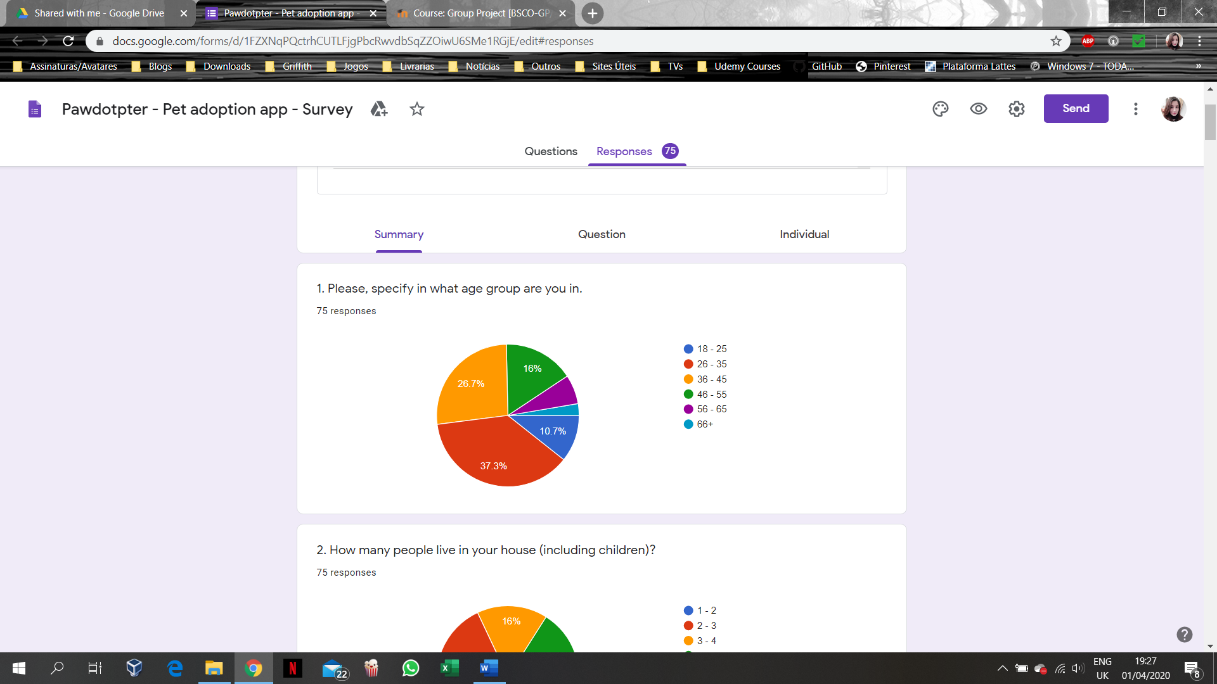

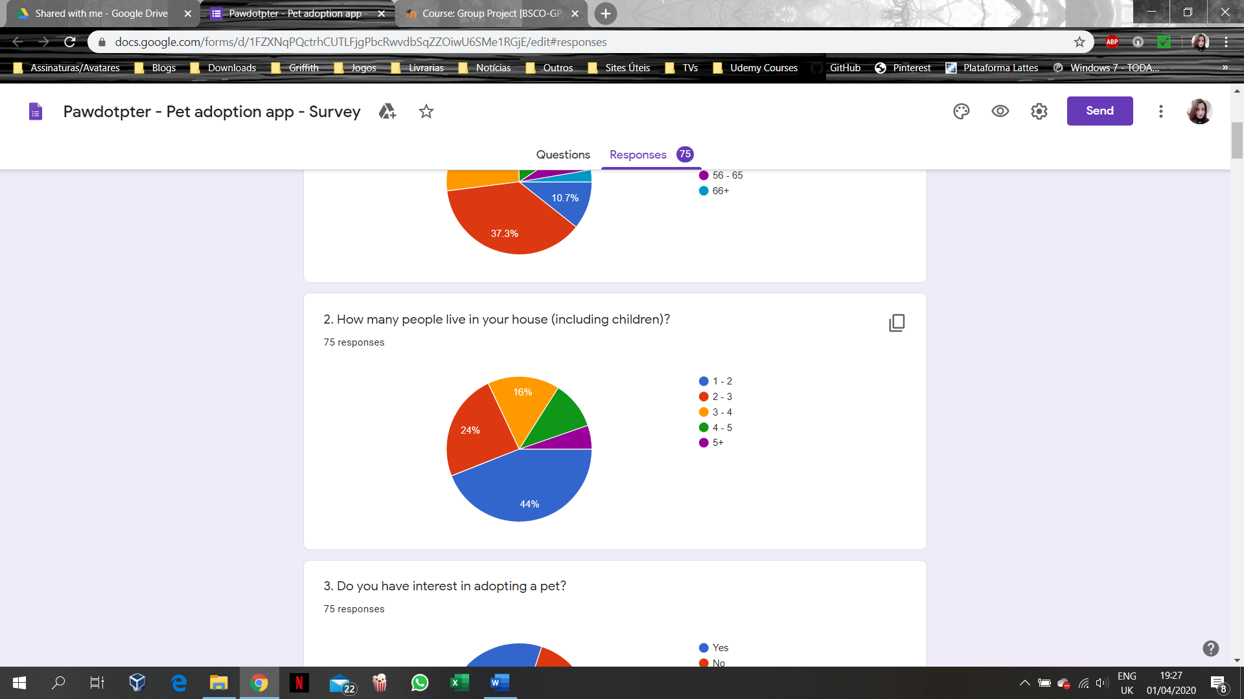

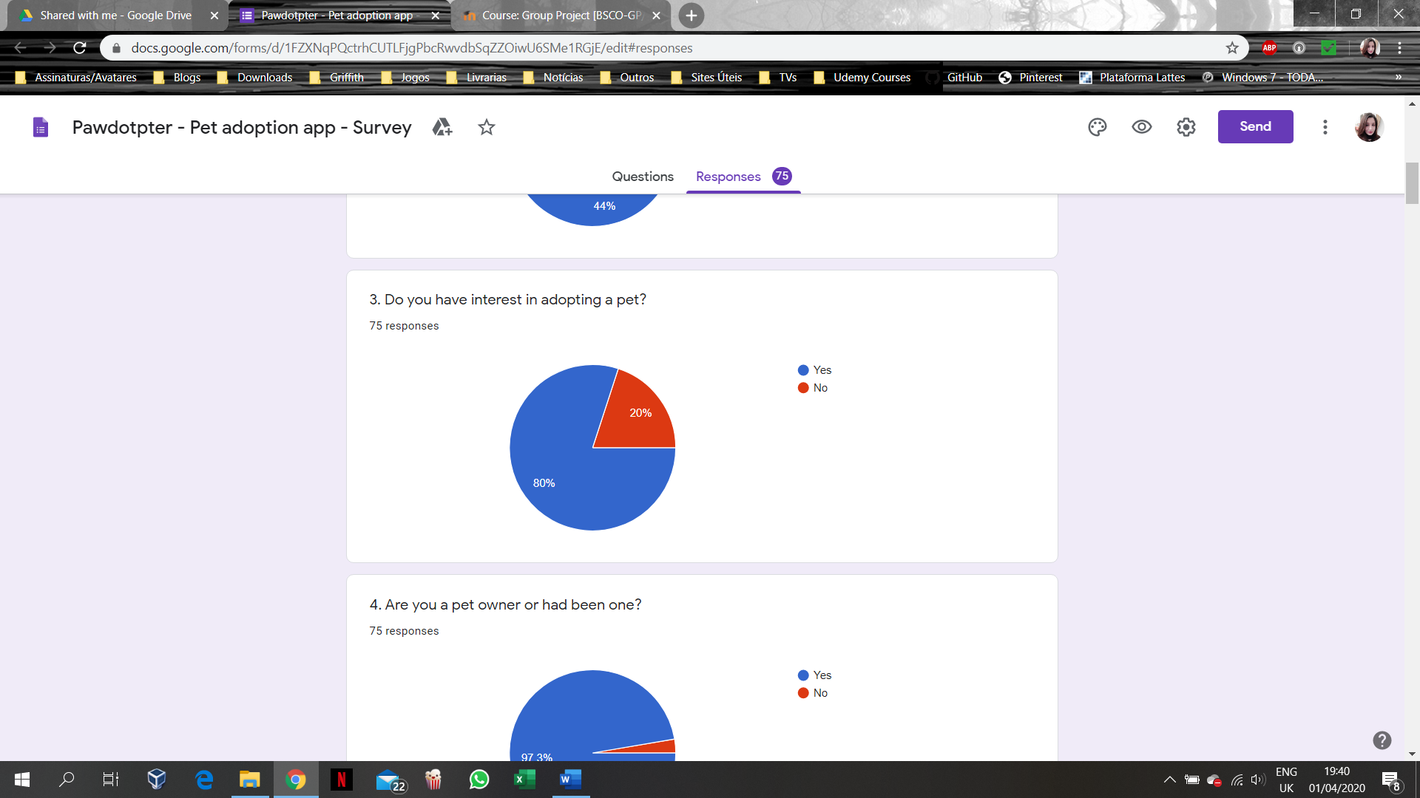

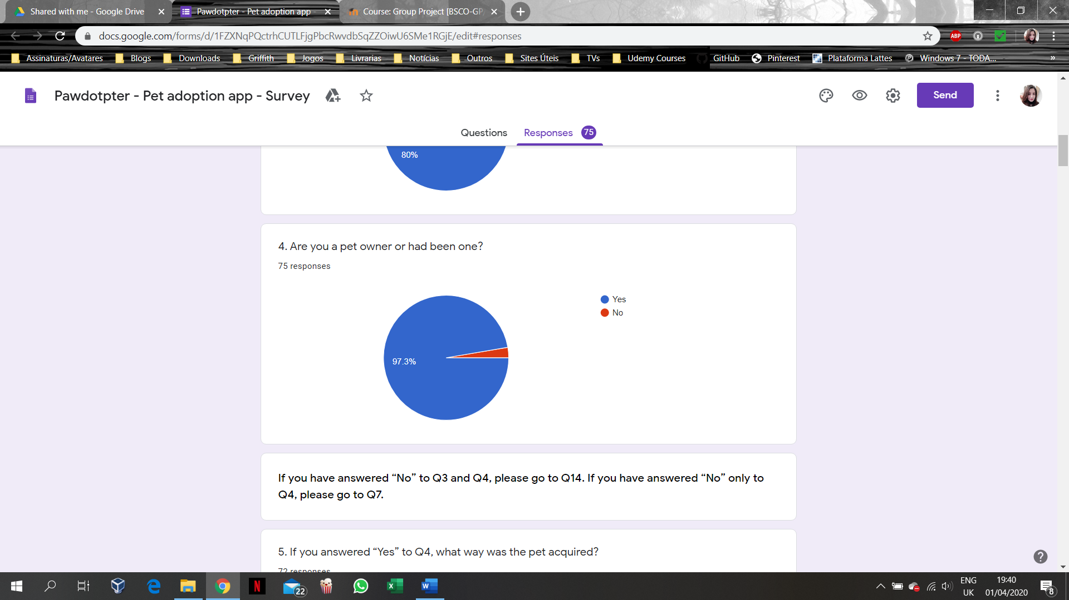

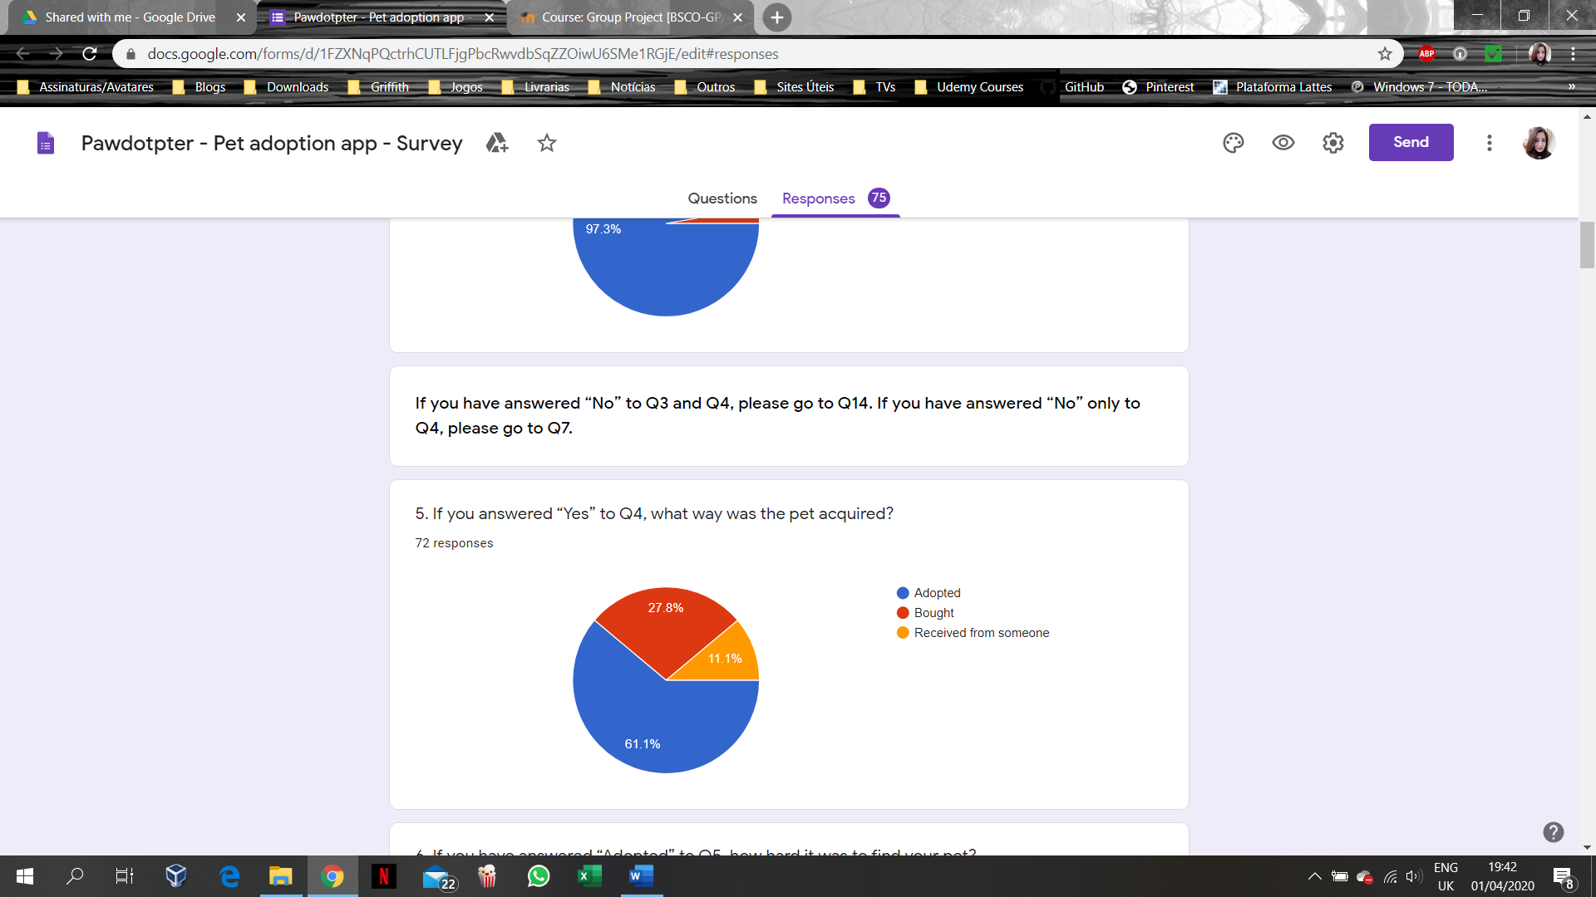



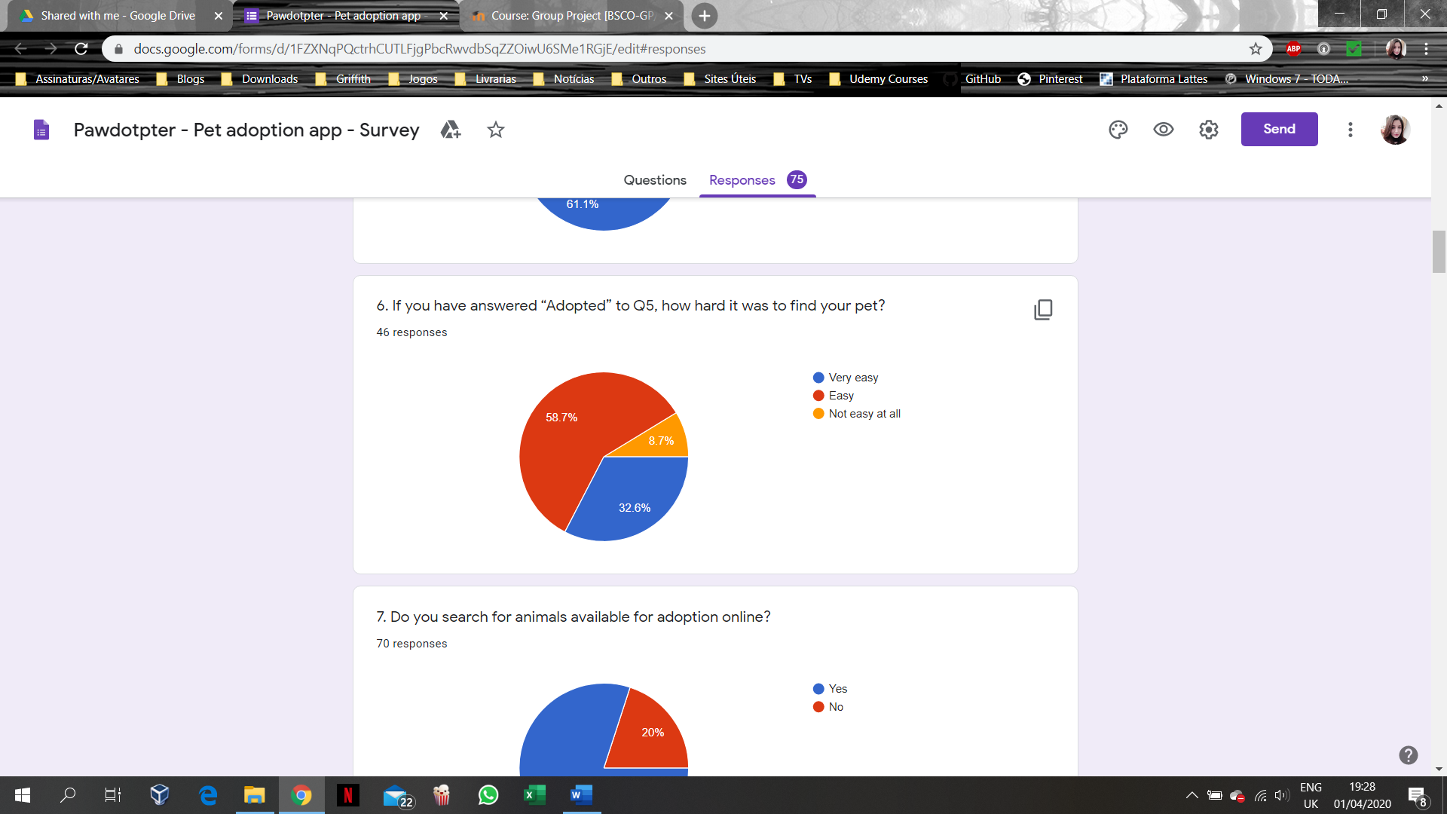

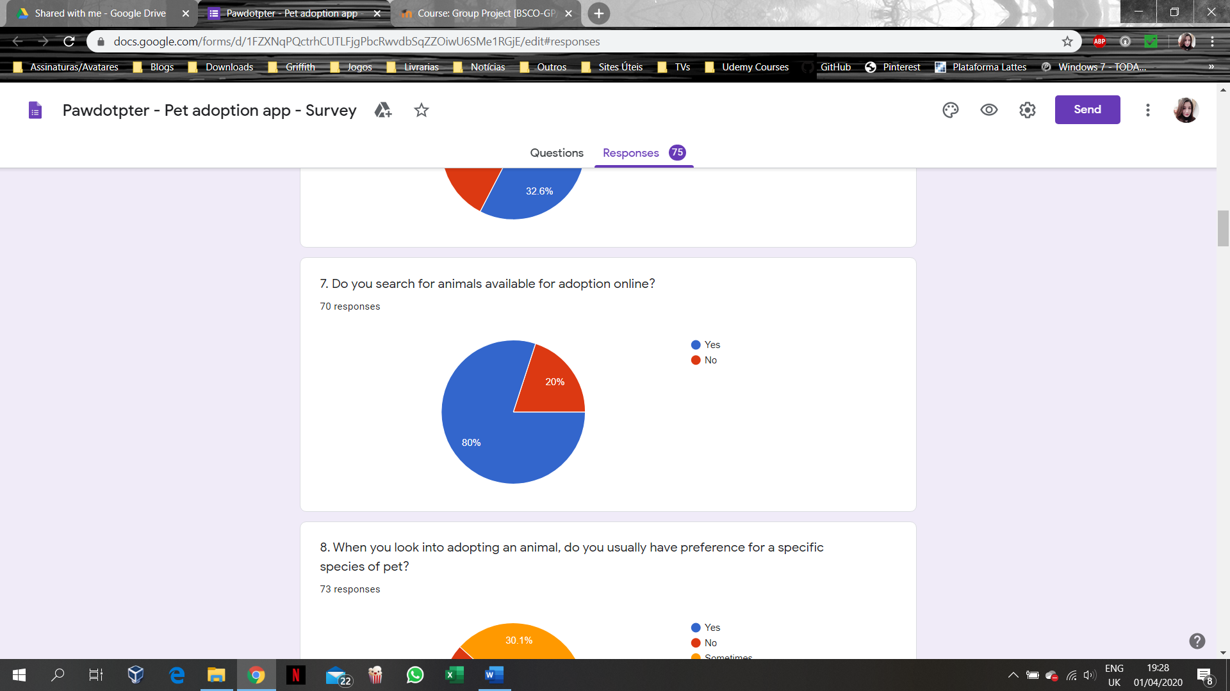

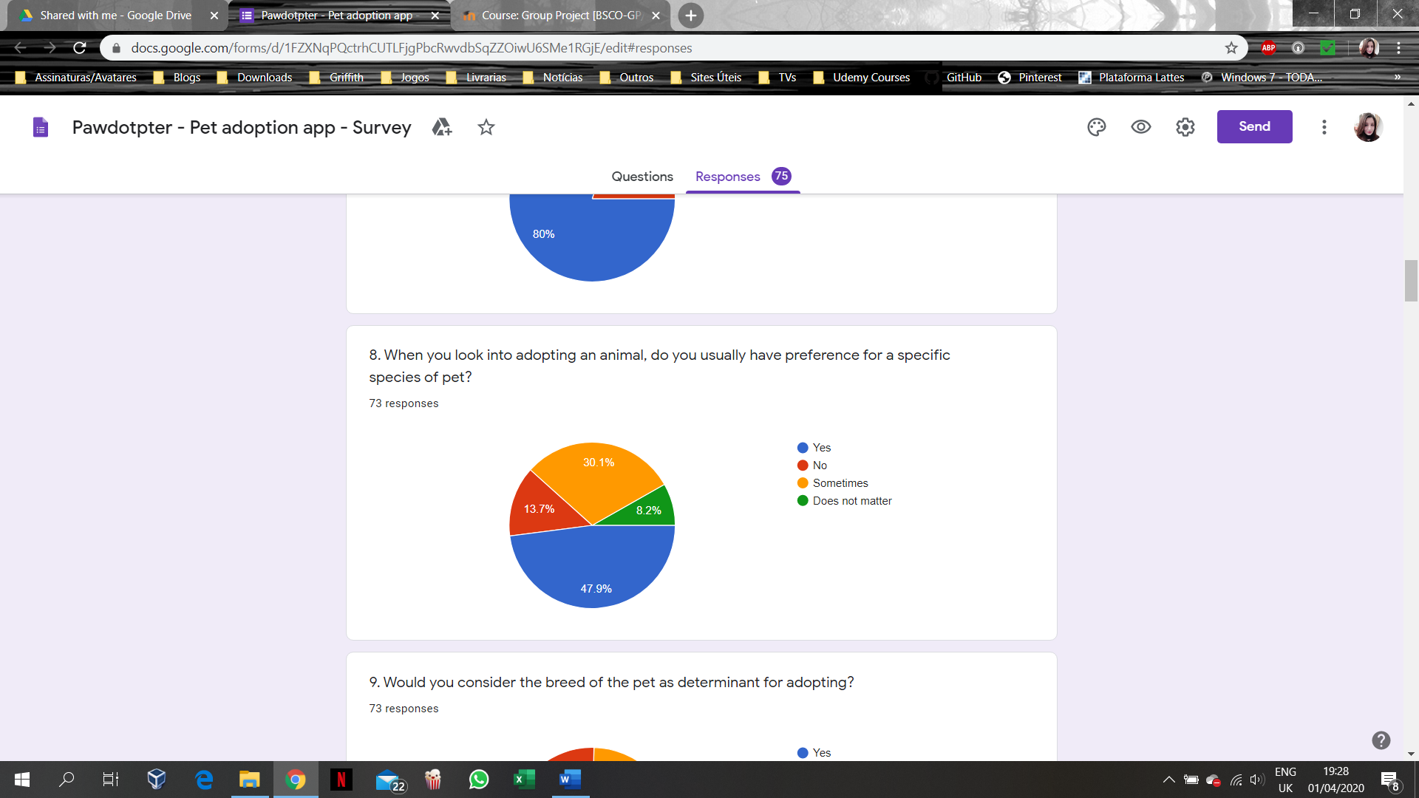

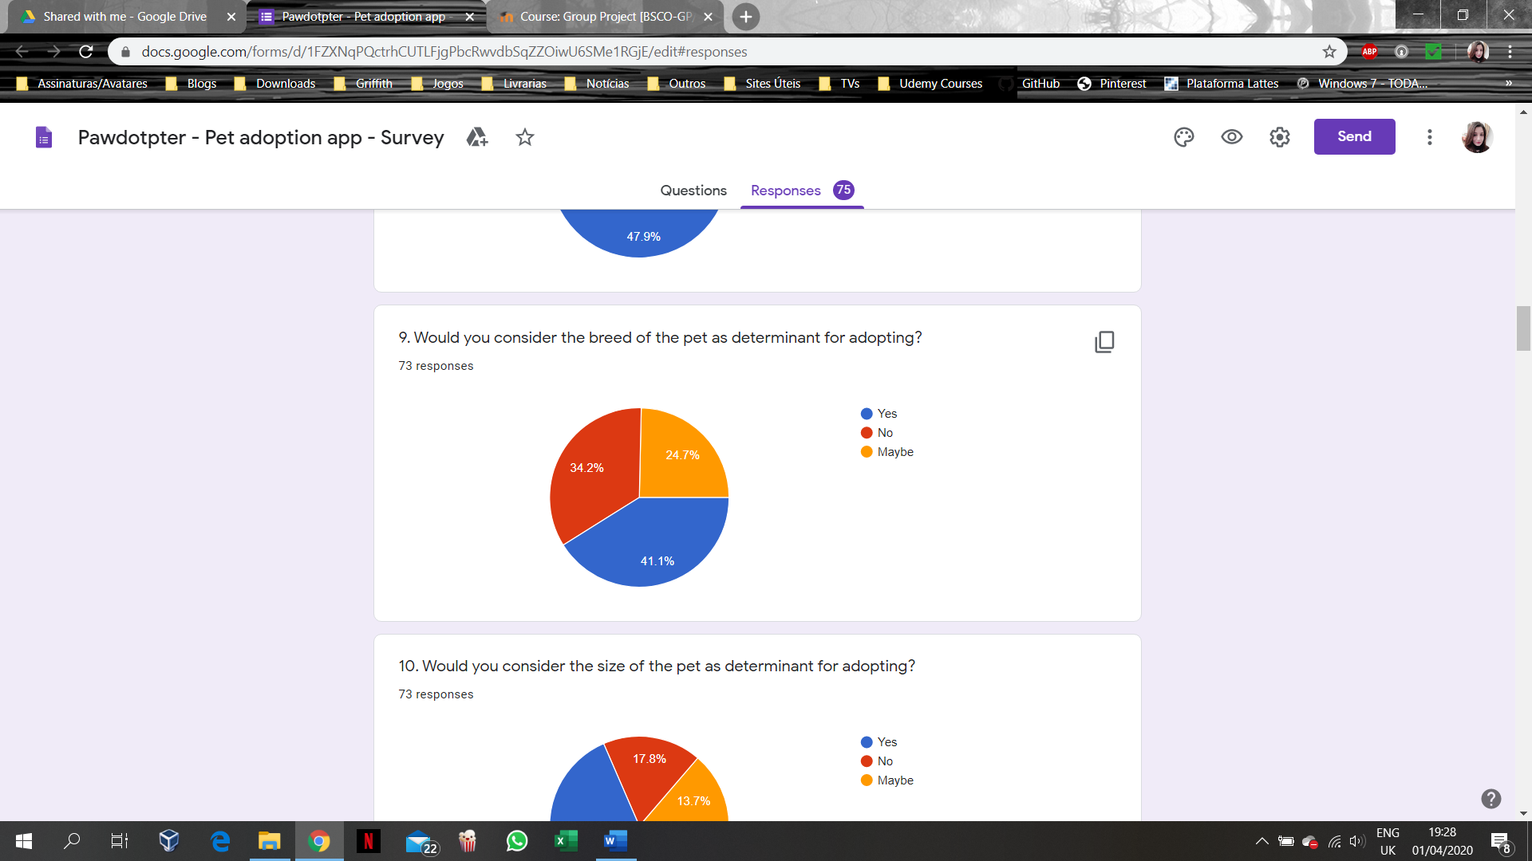

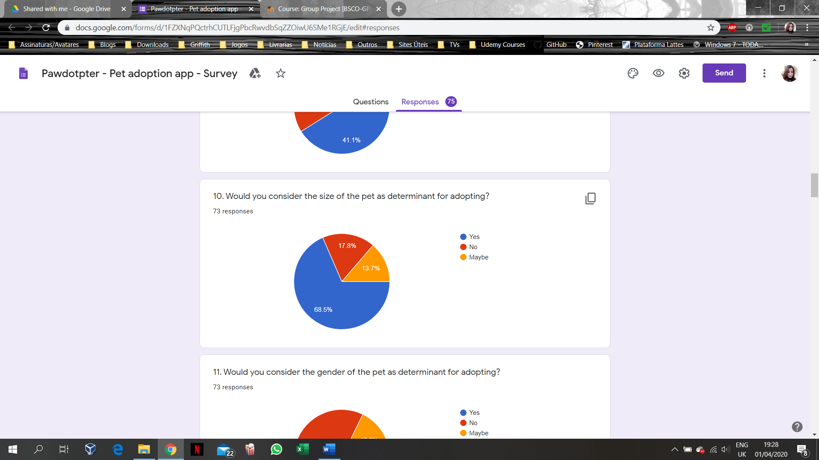

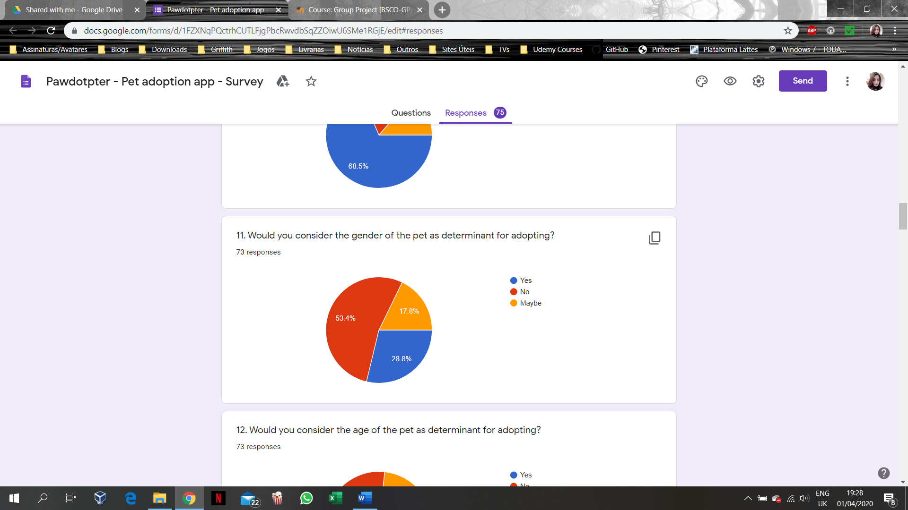

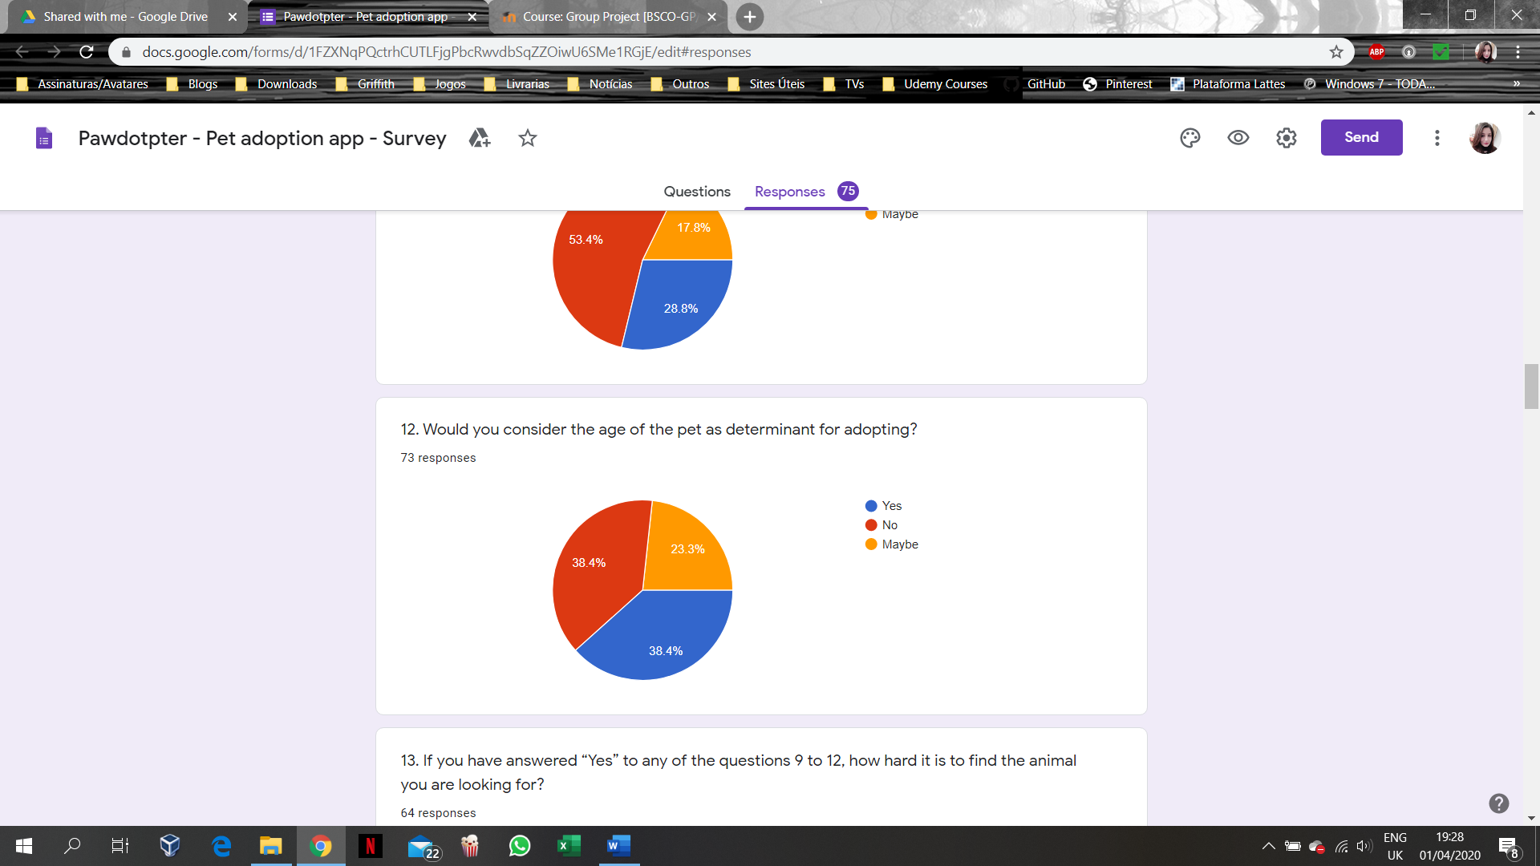

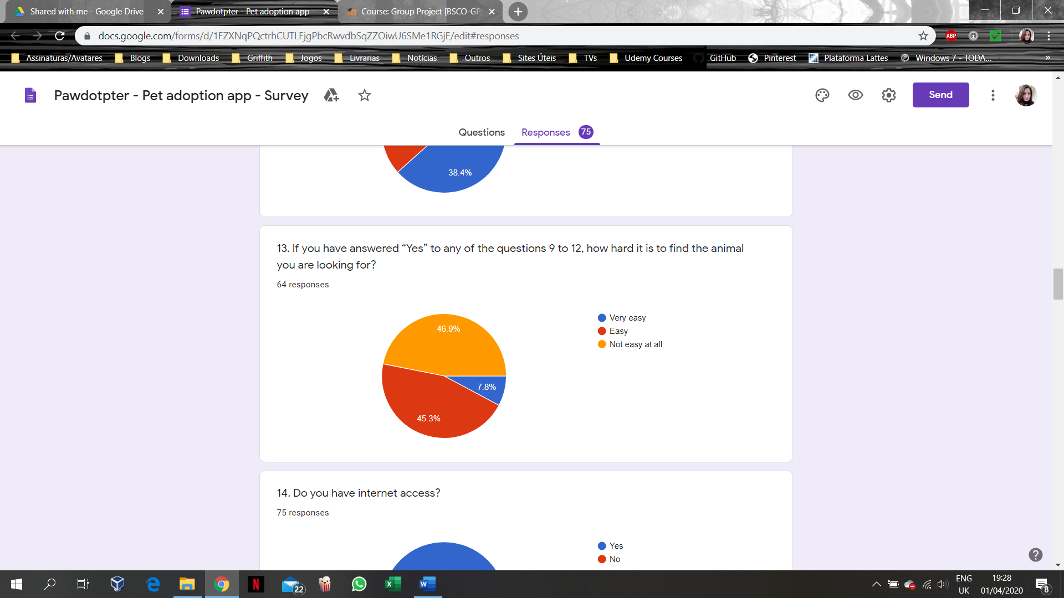

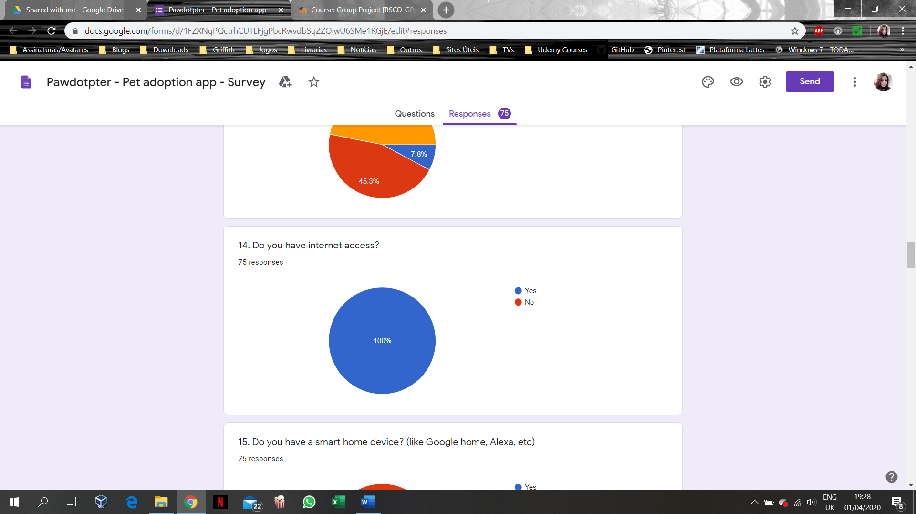

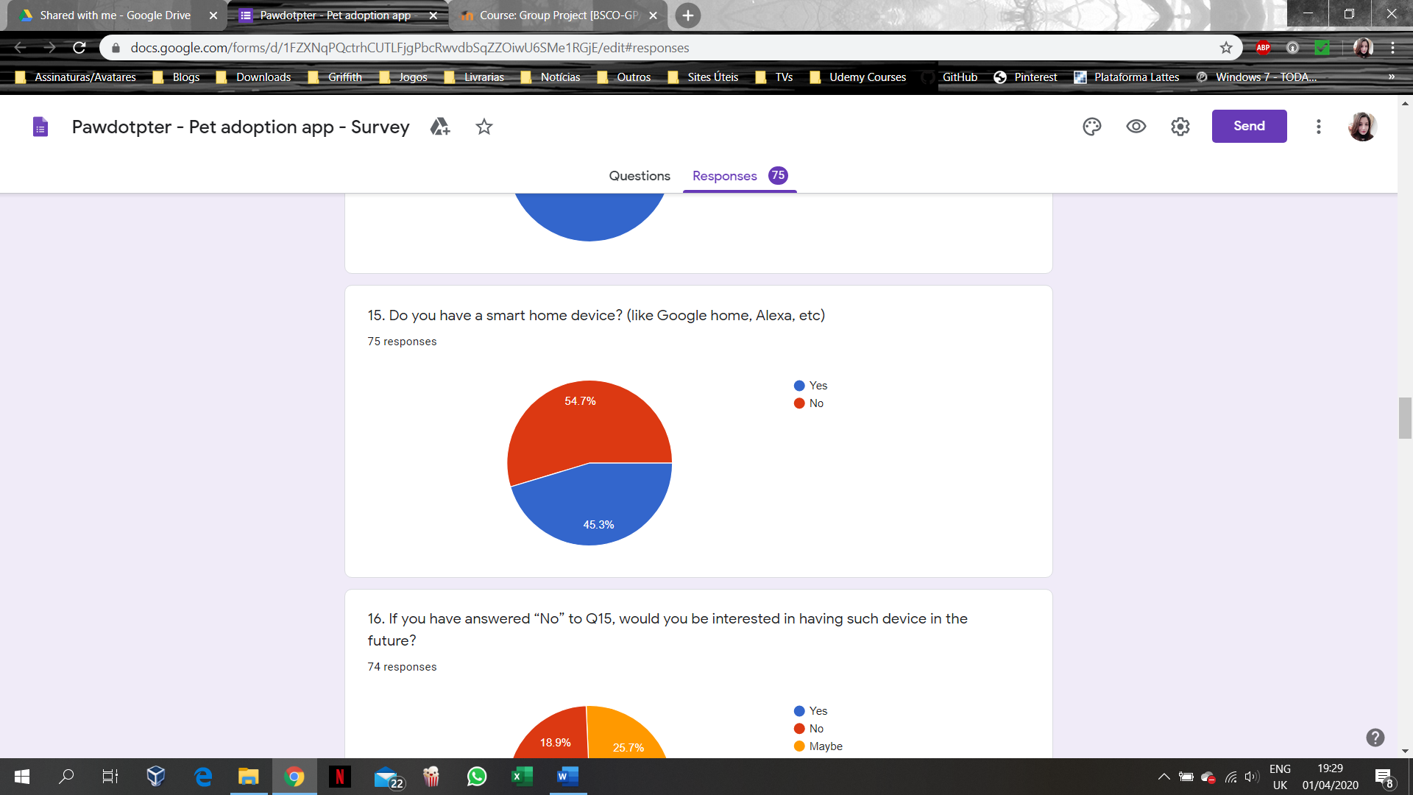

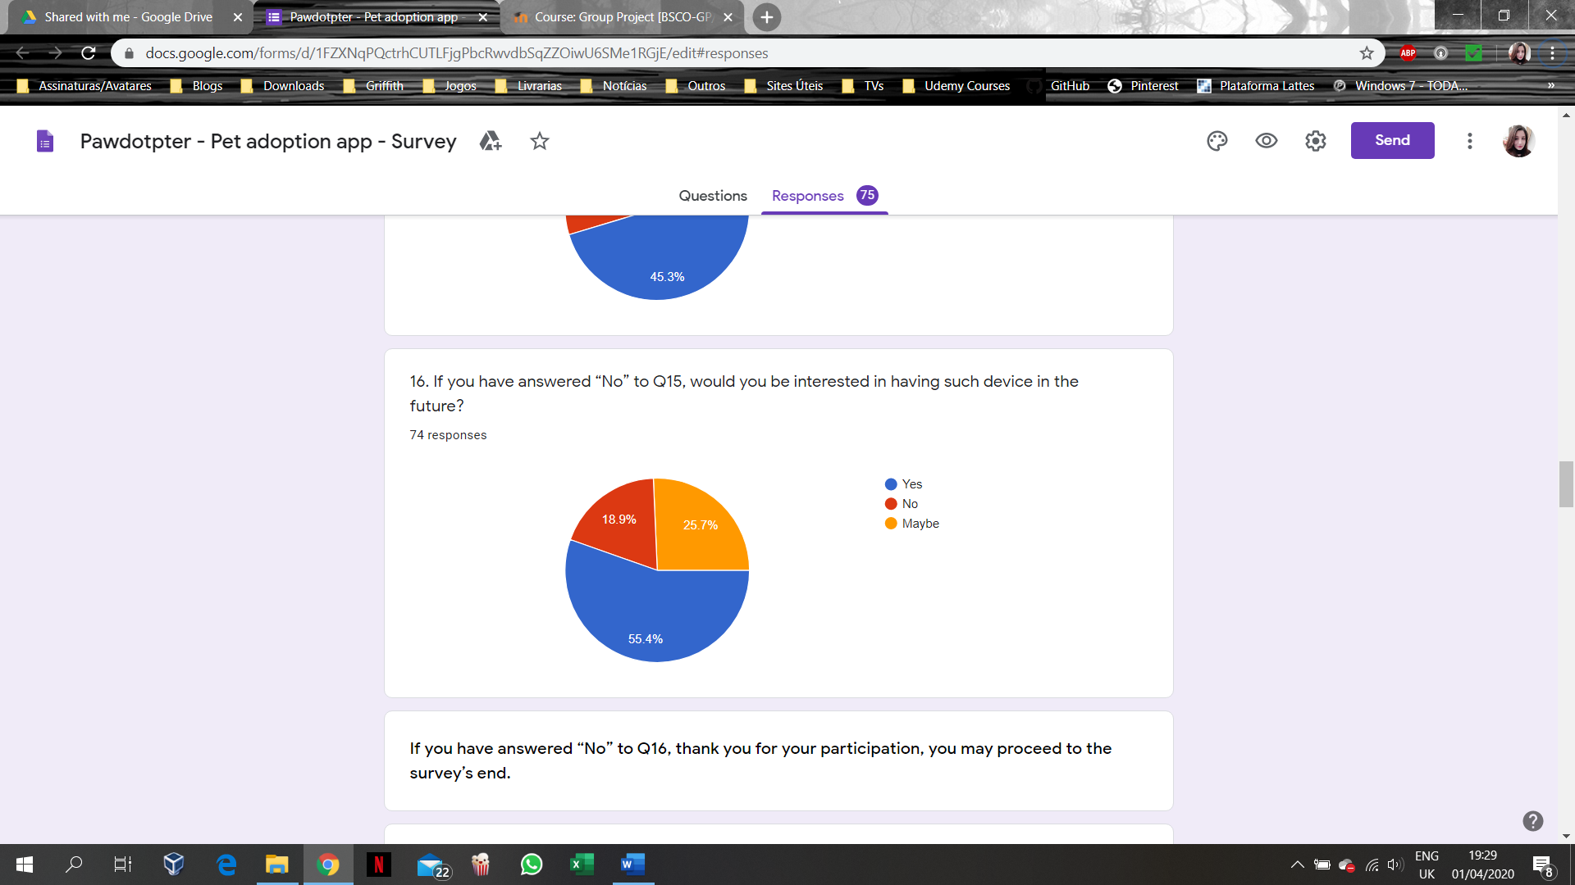

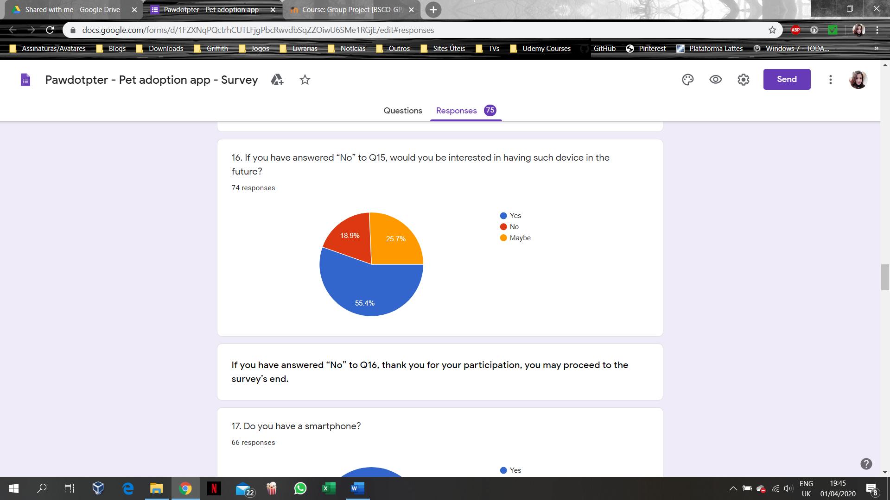

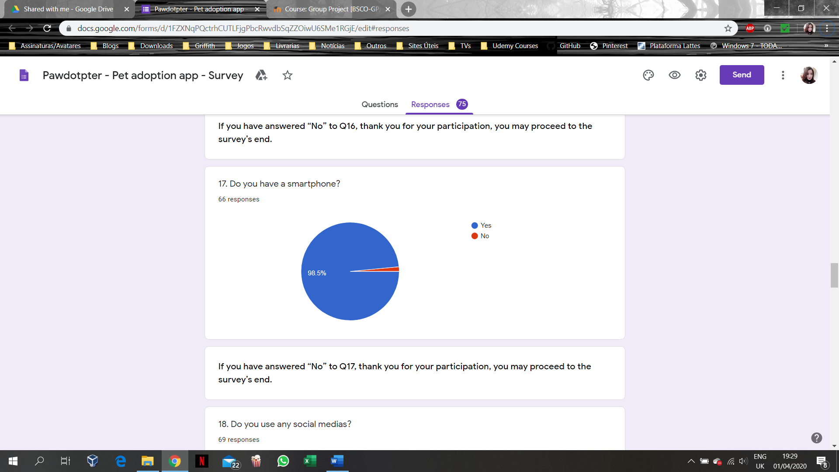

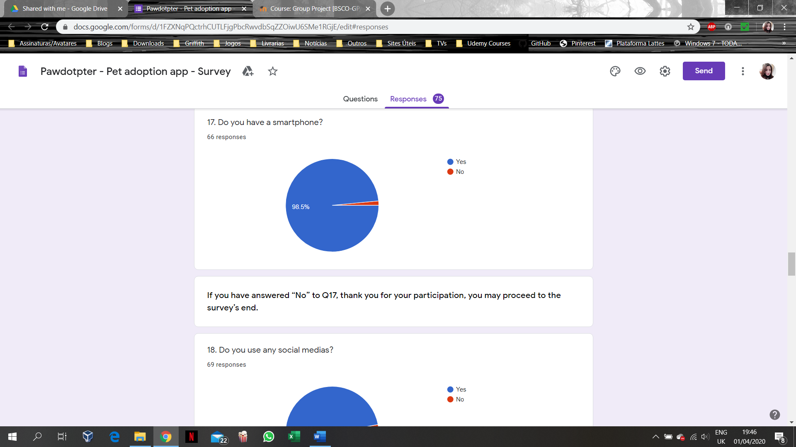

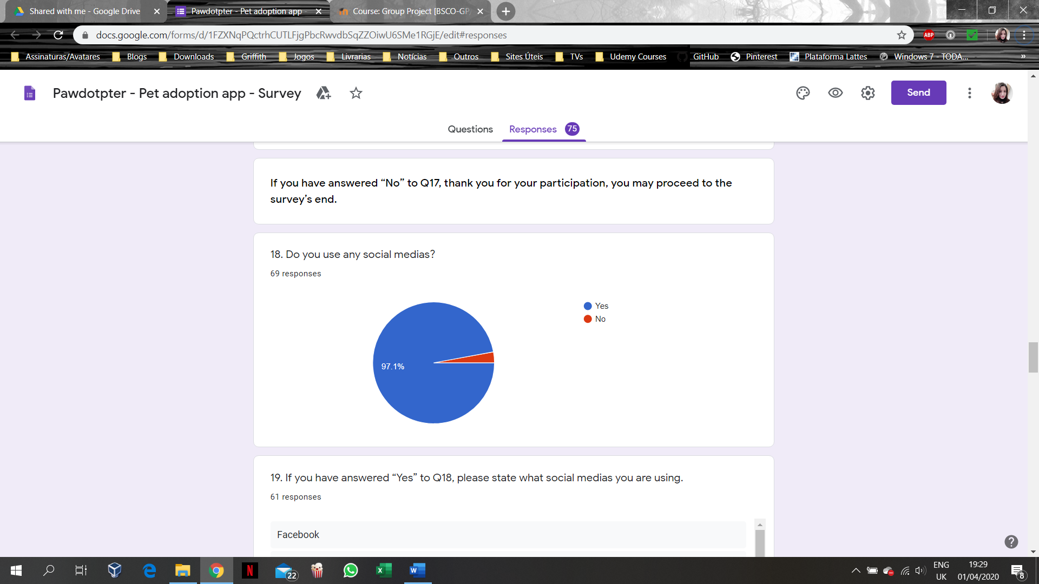

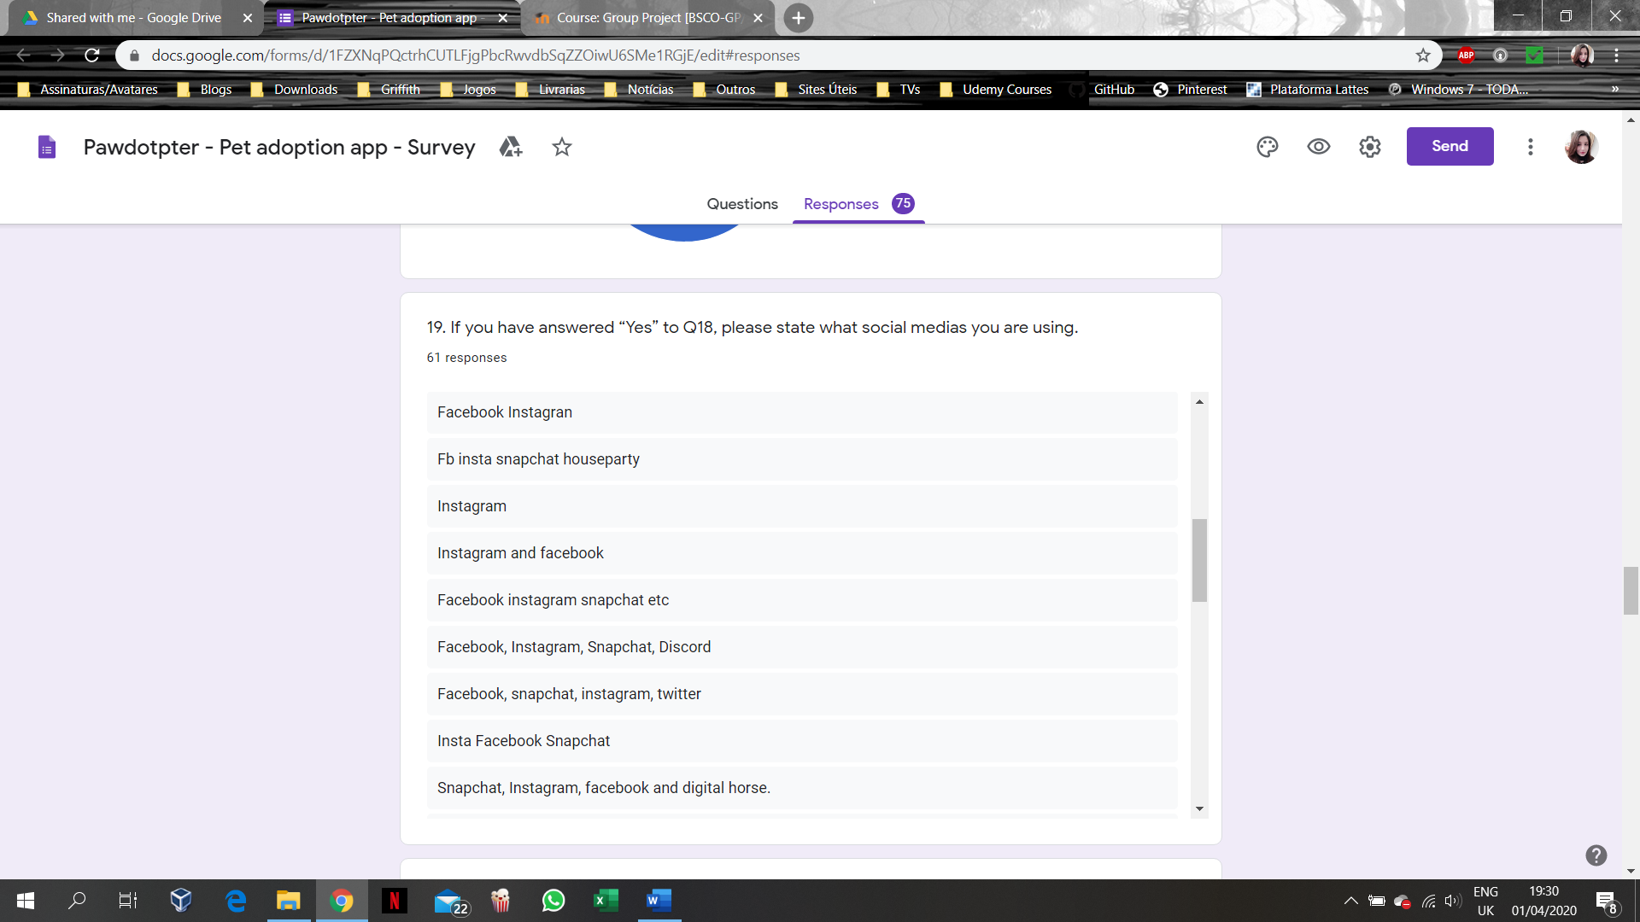

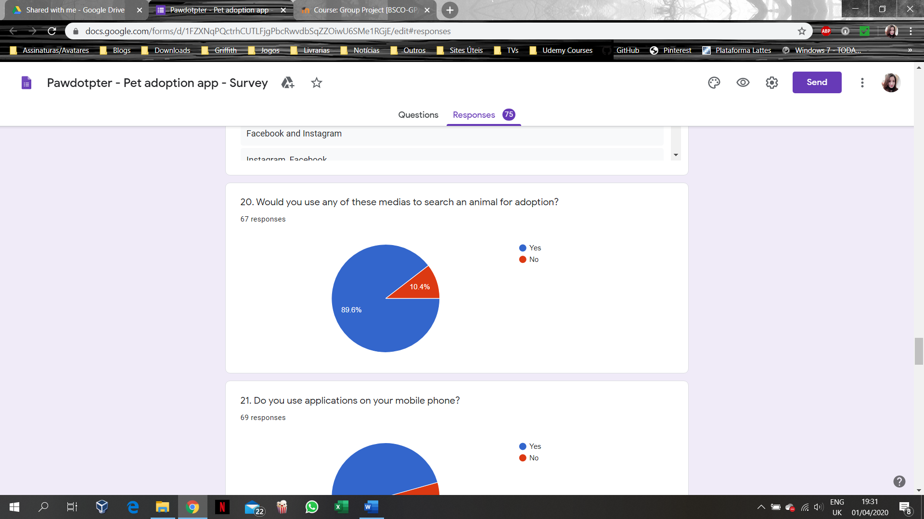

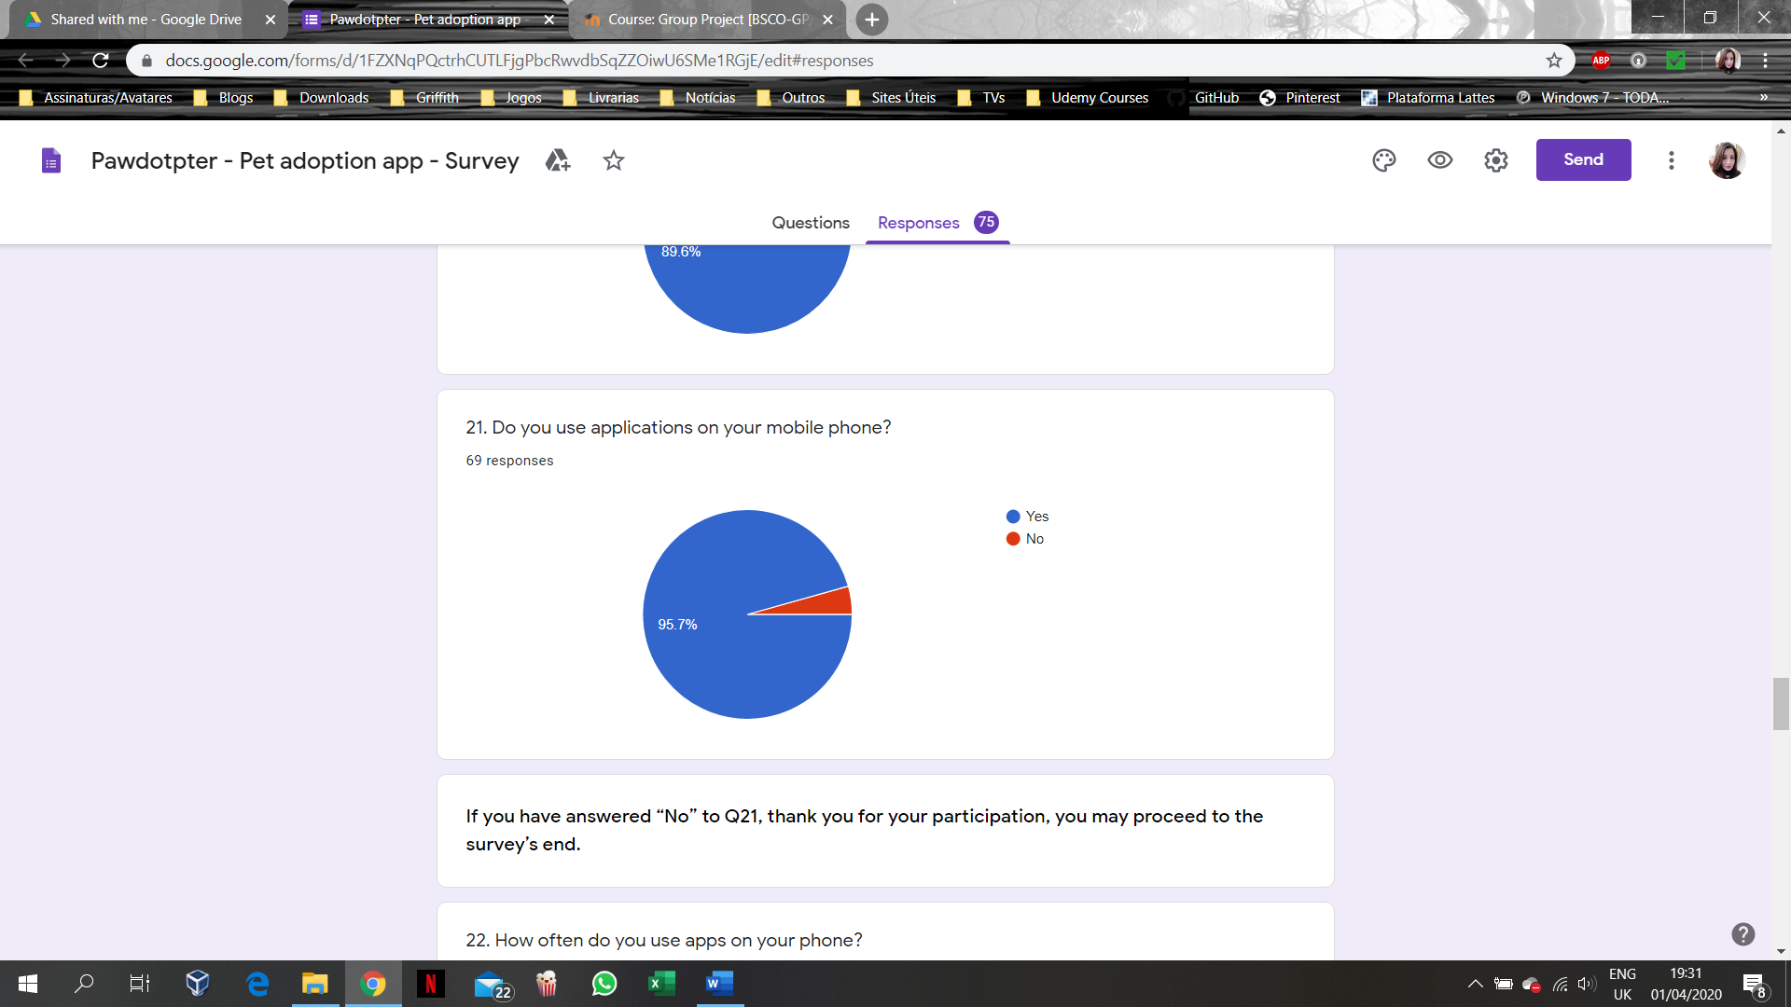

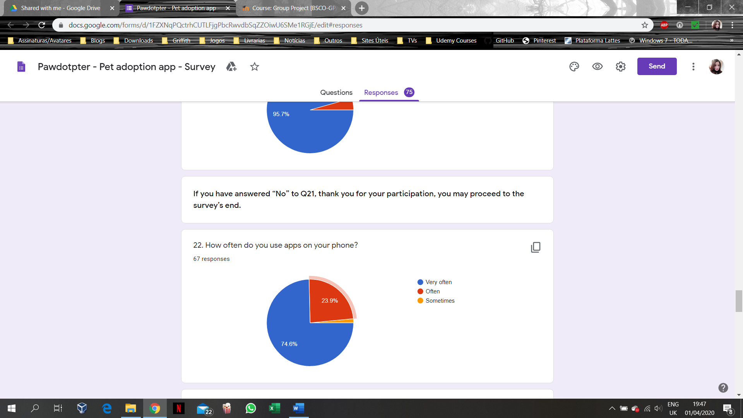

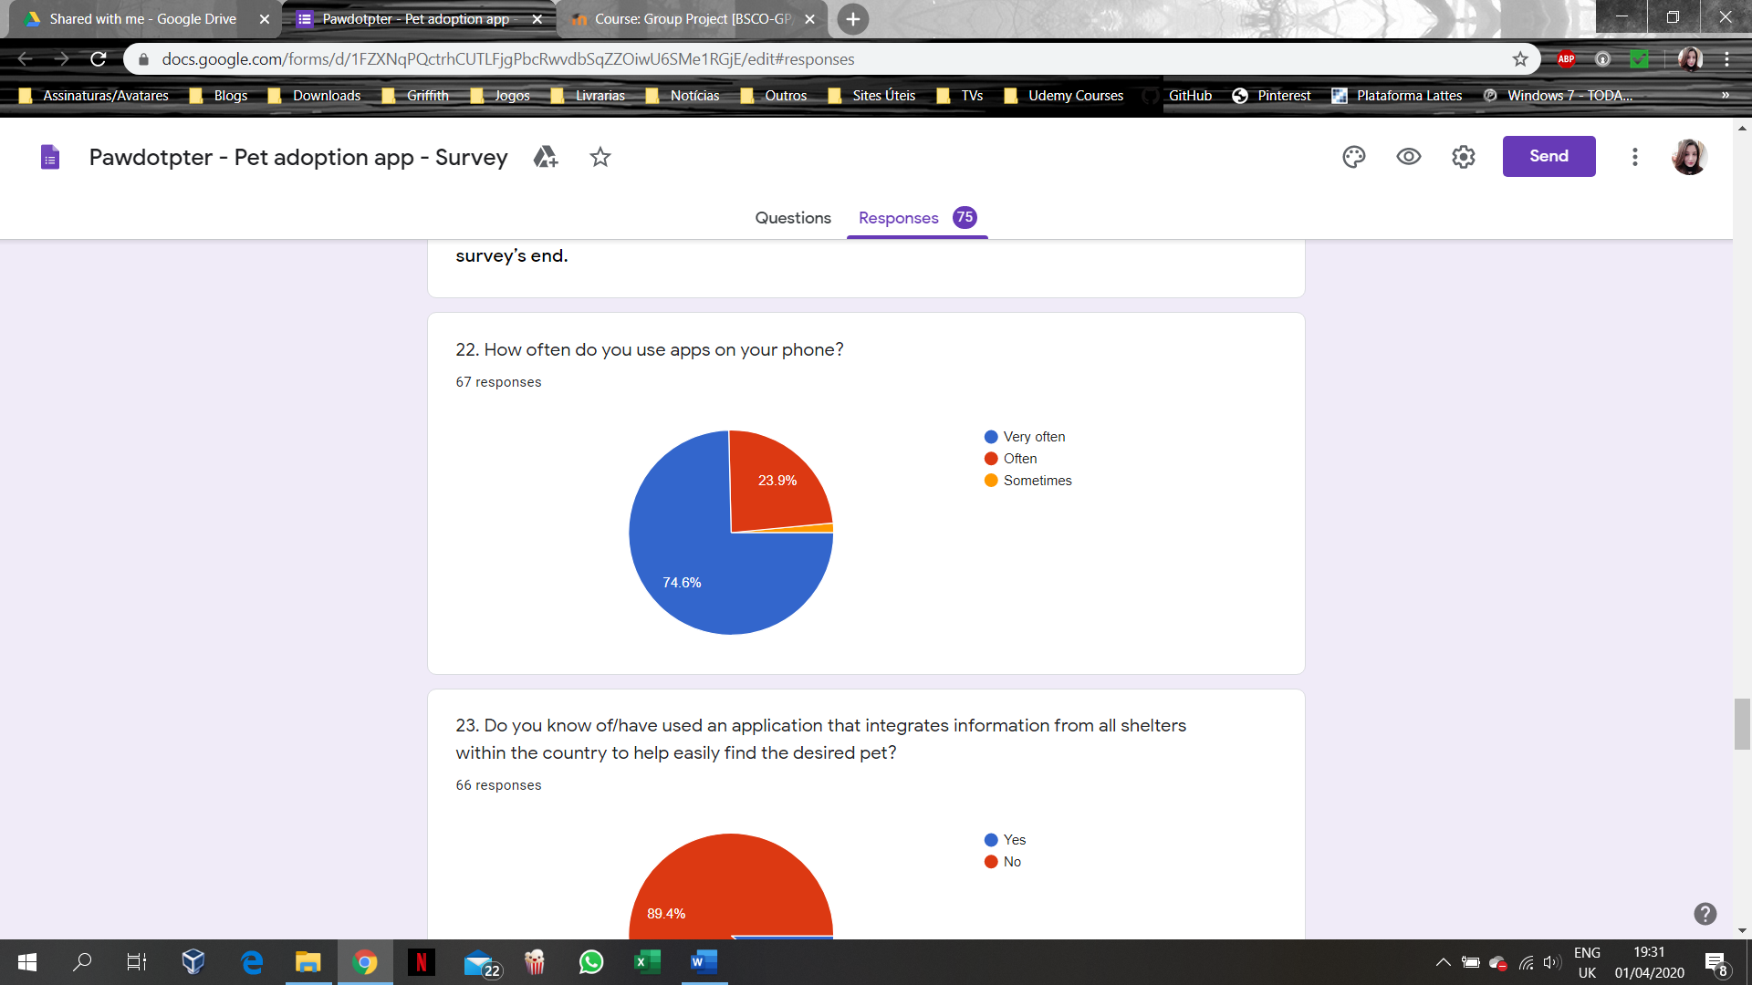

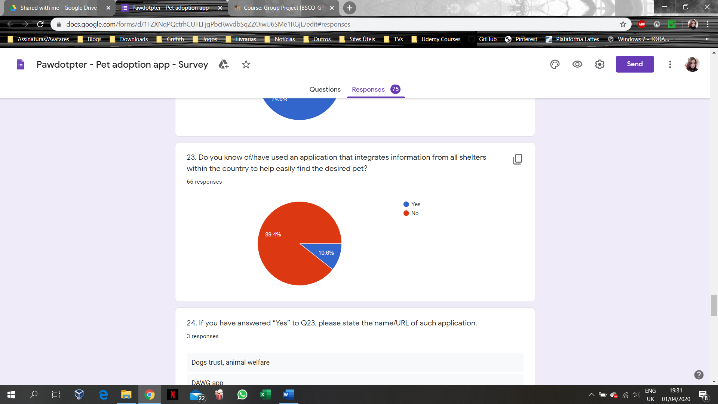

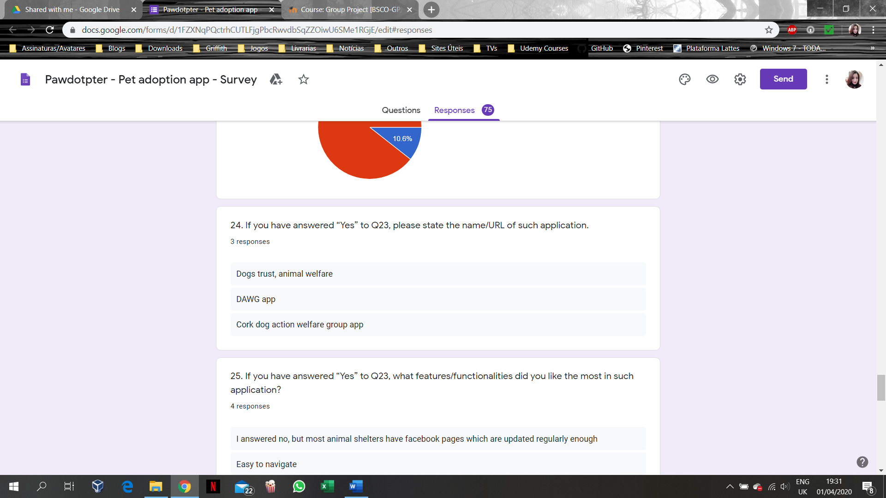

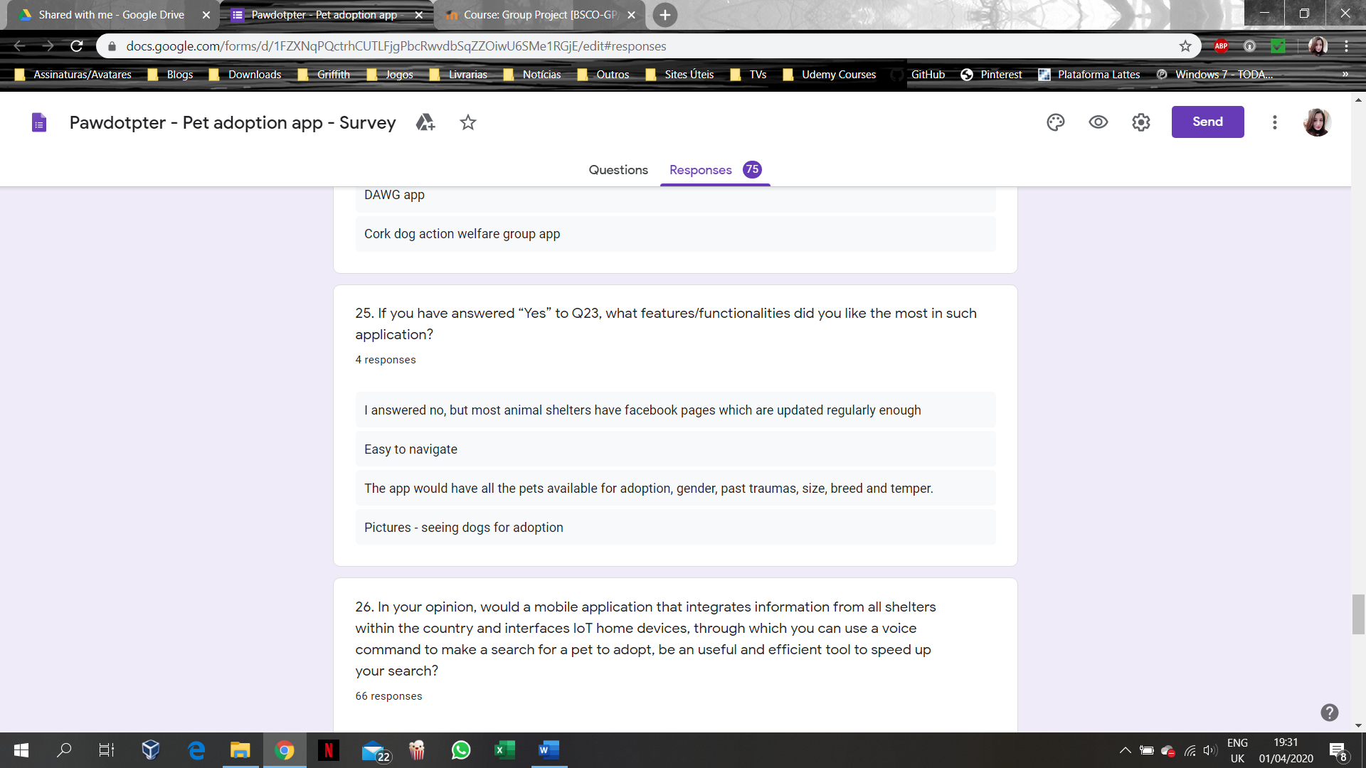

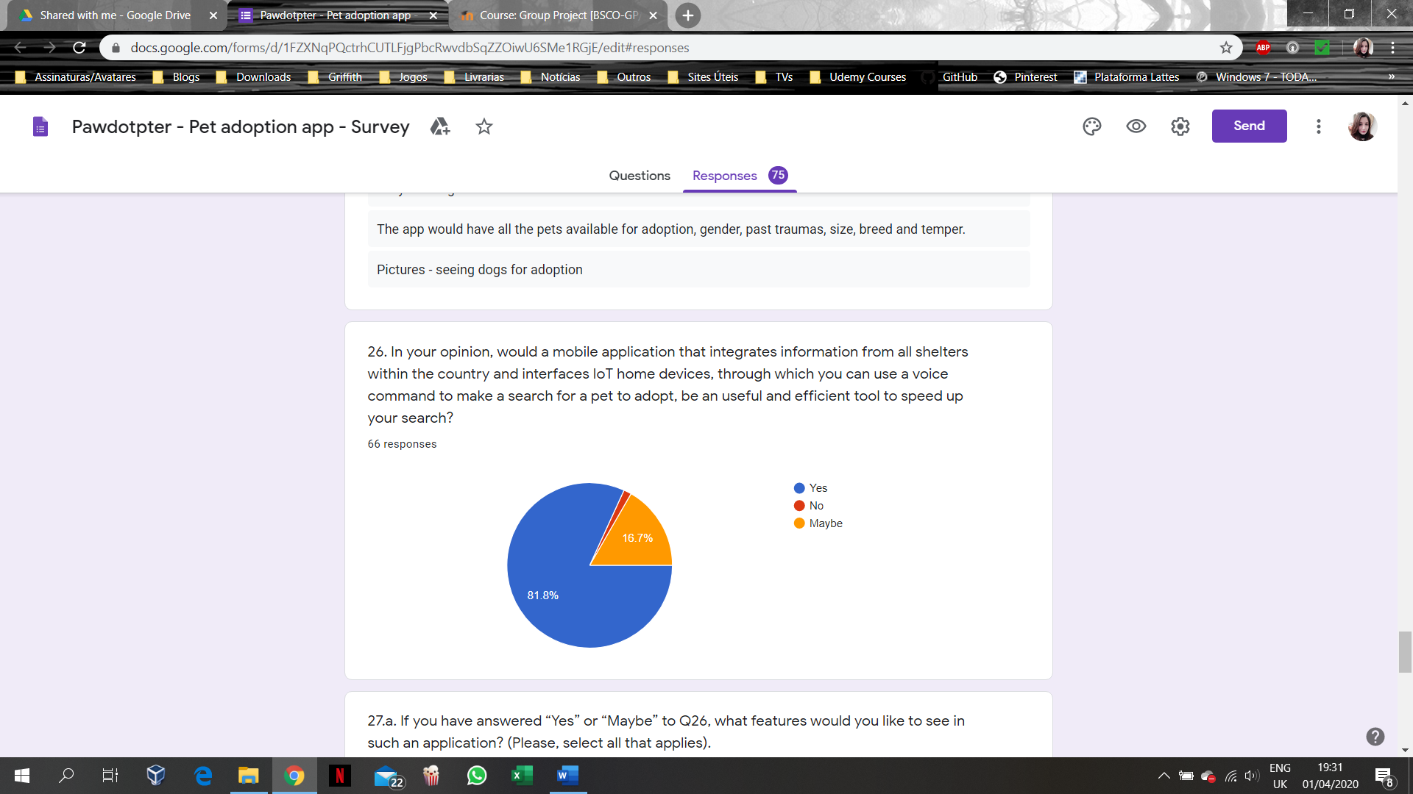

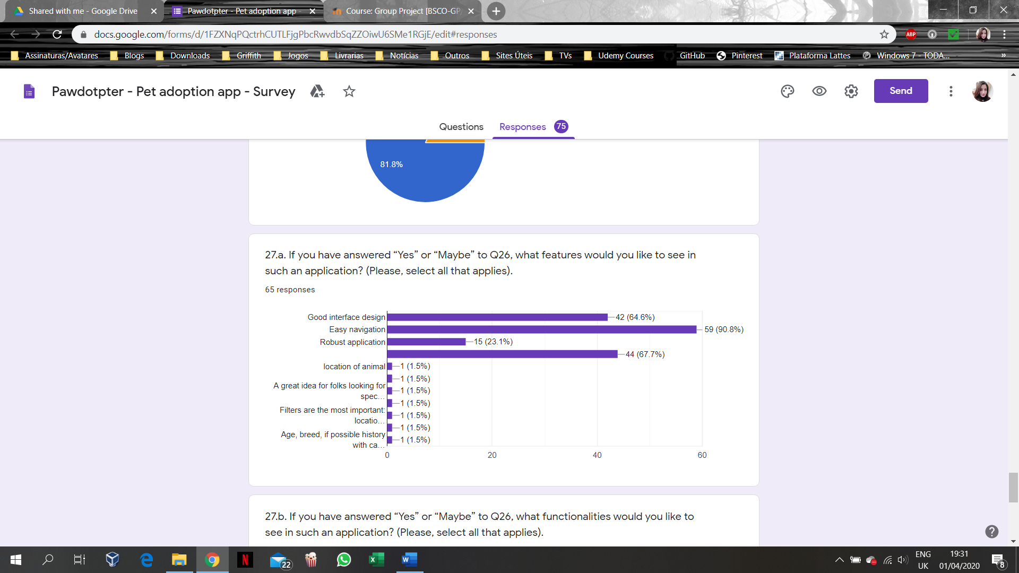

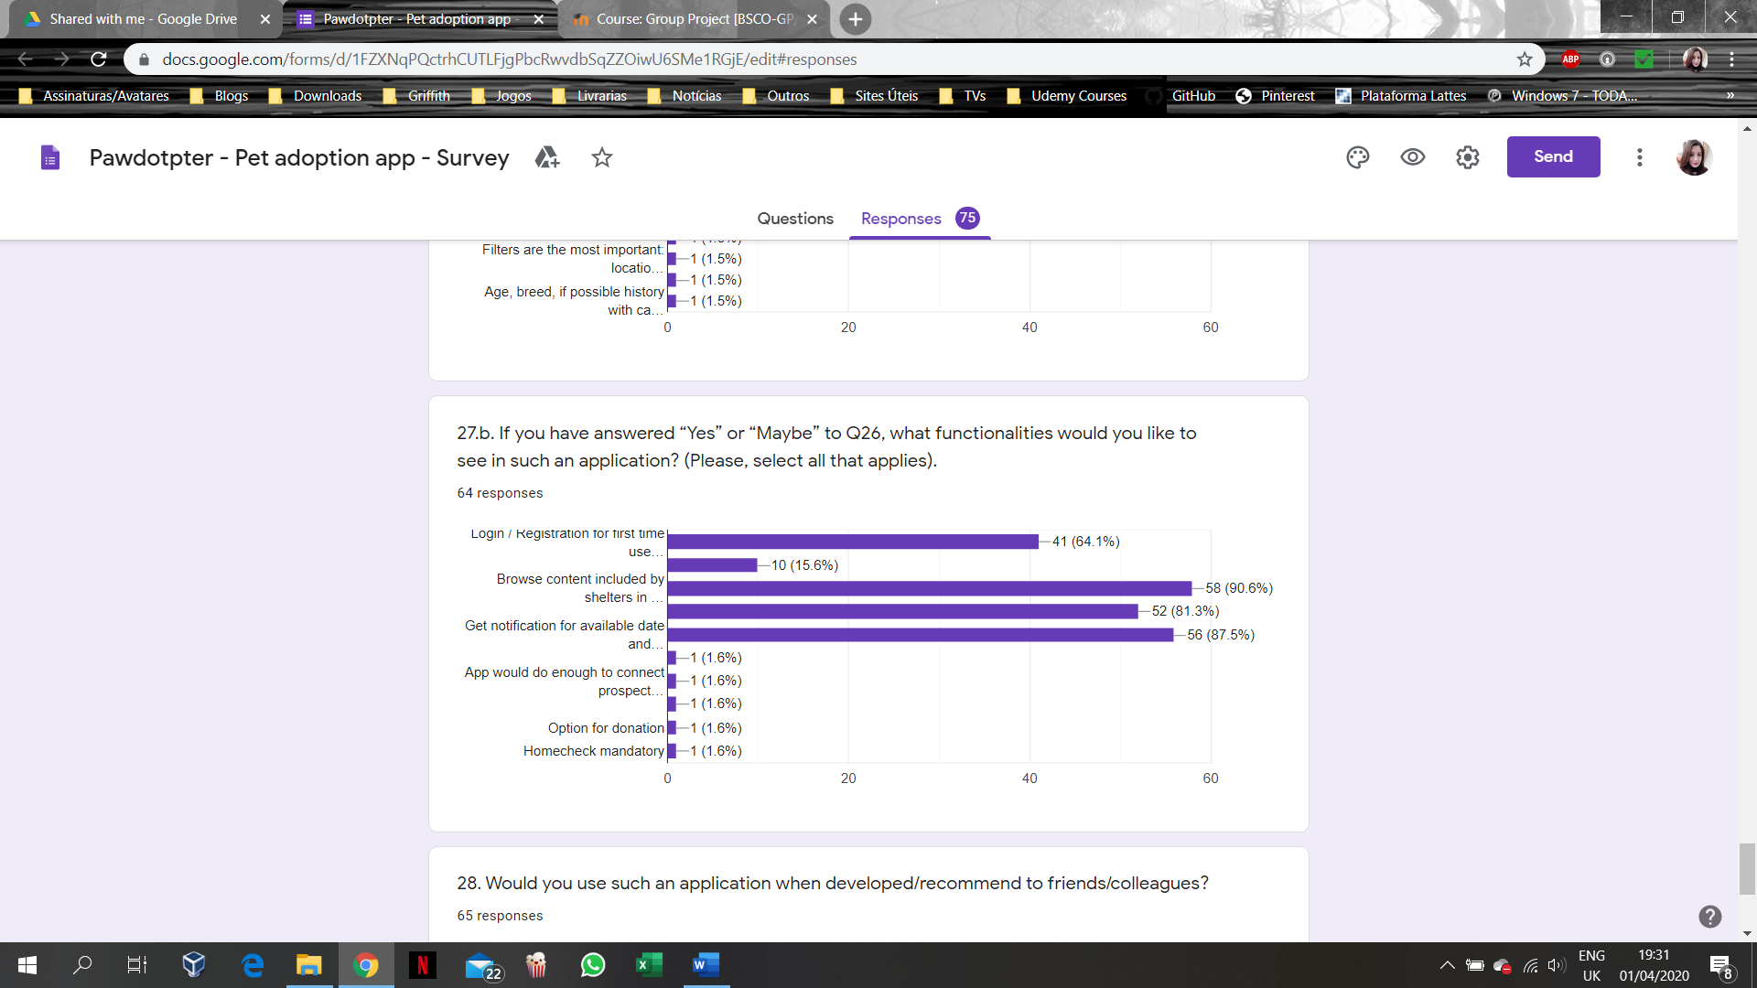

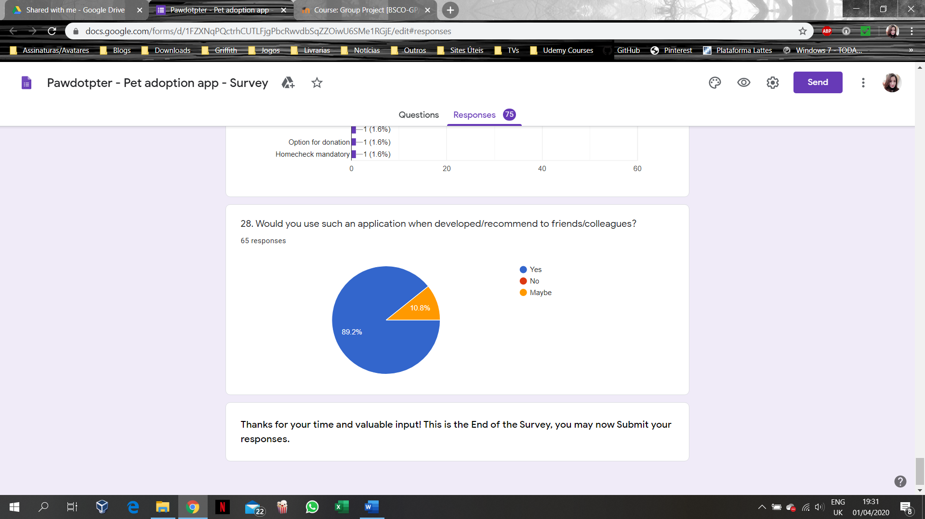

# APPENDIX A3: Structured Interview Questions for Shelter’s Management

